

PENETRATION TEST REPORT

Prepared by

Prepared for: SAMPLECORP LTD v1.0 September | 30 | 2018

.

|

**TABLE OF CONTENTS Document Control iv**

**Executive Summary 1**

**Test Scope 1**

**Results 1**

**Recommendations 2**

**Testing Approach 3**

**Overview 3**

**Discovery & Reconnaissance 4**

**Validation & Exploitation 4**

**Internal Network Findings 5**

**Scope 5**

**Network Penetration Testing Results 5**

Services by Host and by Port 5

Vulnerability Summary Table 8

Details 9

**Web Application Findings 20**

**Scope 20**

**Web Application Results 20**

Web Application Detailed Findings 21

Vulnerability Summary Table 21

Details 21

**Wireless Network Findings 27**

**Scope 27**

**Wireless Network Results 27**

Access via Wi-Fi Penetration Testing Device 27

Wireless Network Reconnaissance 27

Wireless Network Penetration Testing 28

**Mobile Applications Findings 30**

**Scope 30**

**Application Results 30**

Application Detailed Findings 30

Vulnerability Summary Table 30

Details 31

**Social Engineering Findings 37**

**Scope 37**

**Social Engineering Results 37**

Social Engineering Detailed Findings 38

Email Exposure Report 38

Spear Phishing Report 1 38

|

Voice Phishing Report 40

Malicious USB Payloads 48

**Limitations & Risk Scoring 50**

**Limitations 50**

**Risk Rating Score Calculation 50**

**Risk Rating Scale 51**

**Appendix 52**

**DOCUMENT CONTROL**

|  |  |  |  |
| --- | --- | --- | --- |
| **Issue Control** |  | |  |
| **Document Reference** | n/a | **Project Number** | n/a |
| **Issue** | 1.0 | **Date** | 30 October 2017 |
| **Classification** | Confidential | **Author** | Name Of Author |
| **Document Title** | SampleCorp Penetration Test | |  |
| **Approved by** |  | |  |
| **Released by** | Name Of Tester | |  |

|  |  |
| --- | --- |
| **Owner Details** |  |
| **Name** | Name Of Owner |
| **Office/Region** |  |
| **Contact Number** | 01234 567 890 |
| **E-mail Address** | name@primoconnect.co.uk |

|  |  |  |  |
| --- | --- | --- | --- |
| **Revision History** | |  |  |
| **Issue** | **Date** | **Author** | **Comments** |
| 1.0 | 30 September  2018 | Name Of Author |  |
|  |  |  |  |
|  |  |  |  |

**EXECUTIVE SUMMARY**

PrimoConnect conducted a comprehensive security assessment of SampleCorp LTD in order to determine existing vulnerabilities and establish the current level of security risk associated with the environment and the technologies in use. This assessment harnessed penetration testing and social engineering techniques to provide SampleCorp management with an understanding of the risks and security posture of their corporate environment.

TEST SCOPE

The test scope for this engagement included three hosts on the company’s internal network, a businesscritical web application, as well as an internally-developed mobile application. In addition, SampleCorp requested a wireless audit be performed against their Wi-Fi infrastructure, to discover any insecure wireless protocols, unsecured networks, or related security issues. A social engineering assessment was also requested, to judge the responsiveness of company staff when facing a phishing attack.

Testing was performed September 1 – September 21, 2018. Additional days were utilized to produce the report.

Testing was performed using industry-standard penetration testing tools and frameworks, including Nmap, Sniper, Fierce, OpenVAS, the Metasploit Framework, WPScan, Wireshark, Burp Suite, Tcpdump, Aircrack-ng, Reaver, Asleap, and Arpspoof.

RESULTS

The table below includes the scope of the tests performed, as well as the overall results of penetration testing these environments.

|  |  |
| --- | --- |
| NETWORK PENTESTING | **Testing Results** |
| **Internal Network** | **CRITICAL** |
| **Wireless Network** | **LOW** |
| **Web Application** | **HIGH** |
| **Mobile Application** | **HIGH** |
| **Social Engineering Exercises** | **LOW** |

To test the security posture of the internal network, we began with a reconnaissance and host discovery phase during which we used portscans, ARP scans, and OSINT tools to fingerprint the operating systems, software, and services running on each target host. After fingerprinting the various targets and determining open ports and services enabled on each host, we executed a vulnerability enumeration phase, in which we listed all potential vulnerabilities affecting each host and developed a list of viable attack vectors. Finally, in order to weed out false positives and validate any remaining vulnerabilities, we attempted to exploit all vulnerabilities affecting the target hosts. After comprehensive testing, only a few vulnerabilities were discovered to be present in the target hosts, and we were ultimately unable to exploit these issues to compromise the confidentiality, integrity, or availability of any of the external hosts in scope.

Multiple Critical- and High- and Medium-severity issues were found affecting hosts on the SampleCorp internal network, which require immediate remediation efforts in order to secure the company’s environment against malicious attackers.

To test the security posture of the wireless networks in scope, we performed a number of different scans and attempted a range of attacks. Through a rigorous analysis, we found no vulnerabilities affecting the wireless network configuration. The wireless networks have been configured and secured to a high standard.

To test the security of the company’s Android application, we attached a debugging and exploitation framework to a phone with the app installed. Serious security issues were found to affect the app, and we suggest halting use of the app until it is either re-engineered in a more secure manner, or a suitable replacement is found.

To test the company’s preparedness and response to social engineering attacks, we began by utilizing OSINT techniques to scrape the company’s website and social media accounts for target emails. Next, we launched spear phishing campaigns using spoofed email addresses, voice phishing attacks, and physical social engineering attacks using USB sticks loaded with malicious payloads. Although 35.7% of the targeted employees did end up responding to the phishing emails, none of the malicious USBs were plugged in, and no one responded to the voice phishing messages. All in all, SampleCorp appears relatively prepared to defend against social engineering attacks.

RECOMMENDATIONS

The following recommendations provide direction on improving the overall security posture of SampleCorp’s networks and business-critical applications:

1. Ensure that the credentials protecting the Glassfish instance on host 172.16.2.8 are of suitable complexity to prevent brute force attacks, or disable Secure Admin on the instance to prevent remote access to the DAS.
2. Disable Dynamic Method Invocation on host 172.16.2.8, if possible. Alternatively, upgrade to Struts 2.3.20.3, Struts 2.3.24.3 or Struts 2.3.28.1.
3. Require authentication to use the WebDAV functionality on host 172.16.2.8.
4. Restrict access to the distccd service on host 172.16.2.3 (UDP port 3632).
5. Disable the “r” services or edit the .rhosts file to prevent remote access to host 172.16.2.3.
6. Disable the "username map script" option in the smb.conf configuration file on host 172.16.2.3.
7. Upgrade SLMail or mitigate risk by restricting access to the service on host 172.16.2.5.
8. Update the Ninja Forms plugin to version 2.9.43 or higher on the web app located at <http://172.16.2.8:8585/wordpress/>
9. Increase the strength of the password for the “vagrant” administrator account on the web app located at <http://10.0.2.7/wordpress/>
10. Ensure that the all content providers require strict permission for interaction on the Android mobile app.
11. Disable content provider access to the device’s underlying filesystem on the Android mobile app.

# TESTING APPROACH

OVERVIEW

All testing was executed in several related phases.

1. In the planning phase, the rules of engagement were identified, scope of testing and test windows were agreed upon, and testing goals were set.
2. The discovery phase included automated vulnerability scanning along with manual testing to explore and understand the testing target and any vulnerabilities that could be detected by automated tools.
3. The attack phase comprised efforts to exploit any vulnerabilities detected, and to synthesize knowledge gained about the environment, its technology, its users and its function into an escalation of privilege beyond that intended by the customer.
4. The final phase recorded all findings in a manner that supports risk assessment and remediation by the customer. This included the writing of this report.

*Four-Stage*



Reporting



Planning



Discovery



Attack

*Penetration Testing Methodology*

Additionally, the attack phase comprised several distinct steps, executed iteratively as information was discovered.

1. Gained access to the system or environment in a way that was not intended.
2. Escalated privileges to move from regular or anonymous user to a more privileged position.
3. Browsed to explore the newly accessed environment and identify useful assets and data.
4. Deployed tools to attack further from the newly gained vantage point.
5. Exfiltrated data.



Attack Phase



Discovery

Phase

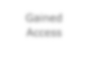

Gain

ed

Access

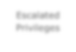

Escalat

ed

Privileges

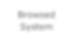

Browsed

System

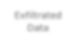

Exfiltrate

d

Data

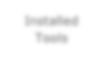

Instal

led

Tools

DISCOVERY & RECONNAISSANCE

As the first step of this engagement, PrimoConnect performed discovery and reconnaissance of the environment. This included performing network or application scans; reviewing the system, network or application architecture; or walking through a typical use case scenario for the environment. The results of discovery and reconnaissance determine vulnerable areas which may be exploited.

VALIDATION & EXPLOITATION

PrimoConnect used the results of the reconnaissance efforts as a starting point for manual attempts to compromise the Confidentiality, Integrity and Availability (CIA) of the environment and the data contained therein.

The highest risk vulnerabilities identified were selectively chosen by the assessor for exploitation attempts. The detailed results of these exploitation and validation tests follow in the sections below. While PrimoConnect may not have had time to exploit every vulnerability found, the assessor chose those vulnerabilities that provided the best chance to successfully compromise the systems in the time available.

**INTERNAL NETWORK FINDINGS**

SCOPE

The following externally accessible IP addresses were within the scope of this engagement:

|  |
| --- |
| **Target IP Addresses** |
| 10.0.2.5 |
| **172.16.2.3** |
| **172.16.2.5** |

Testing was performed using industry-standard penetration testing tools and frameworks, including Nmap, Sniper, Fierce, OpenVAS, Metasploit Framework, Wireshark, and Burp Suite.

NETWORK PENETRATION TESTING RESULTS

|  |  |
| --- | --- |
| **Result Classification** |  |
| **Vulnerabilities Found** | Yes |
| **Exploited – Denial of Service (DoS)** | No |
| **Exploited – Elevation of Privilege (EoP)** | Yes |
| **Exploited – Remote Code Execution (RCE)** | Yes |
| **Exploit Persistence Achieved** | Yes |
| **Sensitive Data Exfiltrated** | Yes |
| **Overall Risk** | **HIGH** |

There were a significant number of exploited vulnerabilities present on the external network target, including a vulnerability in the Oracle Glassfish server, a vulnerability in the Apache Struts REST Plugin, an unrestricted WebDAV upload vulnerability, misconfigured ‘r’ services, a vulnerability in the DistCC daemon, a Samba RCE vulnerability, and a buffer overflow vulnerability in the SLMail application, all of which led to system compromise of the affected hosts.

## Services by Host and by Port

As the first step in the Discovery phase, PrimoConnect conducted network reconnaissance on the provided IP addresses to determine open ports. Each IP address was tested for all TCP and UDP ports by using standard scanning tools like Nmap and Sparta. The following ports were identified, and ports with exploitable vulnerabilities are highlighted.

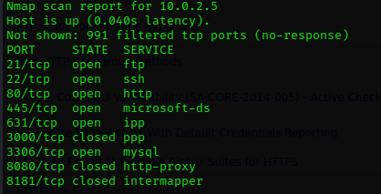

## Vulnerability Summary Table

PrimoConnect strongly recommends that the following vulnerabilities be remediated, whether exploited or not, as they represent unnecessary risk to the organization’s overall security posture.

|  |  |  |  |
| --- | --- | --- | --- |
| **# Vulnerability Summary Risk Level Recommendations** | | | |
| **1** | Sun/Oracle GlassFish Server Authenticated  Code Execution | **CRITICAL** | Ensure that the credentials protecting the Glassfish instance are suitably complex. Secure Admin can also be disabled on the instance to prevent remote access to the DAS. |
| **2** | Apache Struts REST Plugin with Dynamic  Method Invocation Remote Code Execution | **HIGH** | Disable Dynamic Method  Invocation if possible. Alternatively upgrade to Struts 2.3.20.3, Struts  2.3.24.3 or Struts 2.3.28.1. |
| **3** | Unauthenticated WebDAV Upload | **MEDIUM** | Require authentication to use the server’s WebDAV functionality. |
| **4** | DistCC Daemon Command Execution | **CRITICAL** | Restrict access to the distccd service on UDP port 3632 |
| **5** | Misconfigured “r” Services Vulnerability | **CRITICAL** | Disable the “r” services or edit the .rhosts file to prevent remote access |
| **6** | Samba "username map script" Command  Execution | **MEDIUM** | Disable the "username map script" option in the smb.conf configuration file. |
| **7** | Seattle Lab Mail 5.5 POP3 Buffer Overflow | **HIGH** | Upgrade SLMail or mitigate risk by restricting access to the service. |

## Details

|  |  |
| --- | --- |
| **1.** | |
| **Risk** | **CRITICAL** |
| **Locations(s)** | 10.0.2.7 |
| **Description** | |

Unspecified vulnerability in Oracle Sun GlassFish Enterprise Server 2.1, 2.1.1, and 3.0.1, and Sun Java System Application Server 9.1, allows remote attackers to affect confidentiality, integrity, and availability via unknown vectors related to Administration.

Two Metasploit modules exist which can be used to exploit this vulnerability.

### Observations

Using the

auxiliary/scanner/http/glassfish_login

Metasploit module, we

attempted to either bypass the authentication controls protecting the

Glassfish instance or bruteforce

the login credentials. Our attempt at

authentication bypass failed, but we did successfully bruteforce the

administrator credentials to the instance:

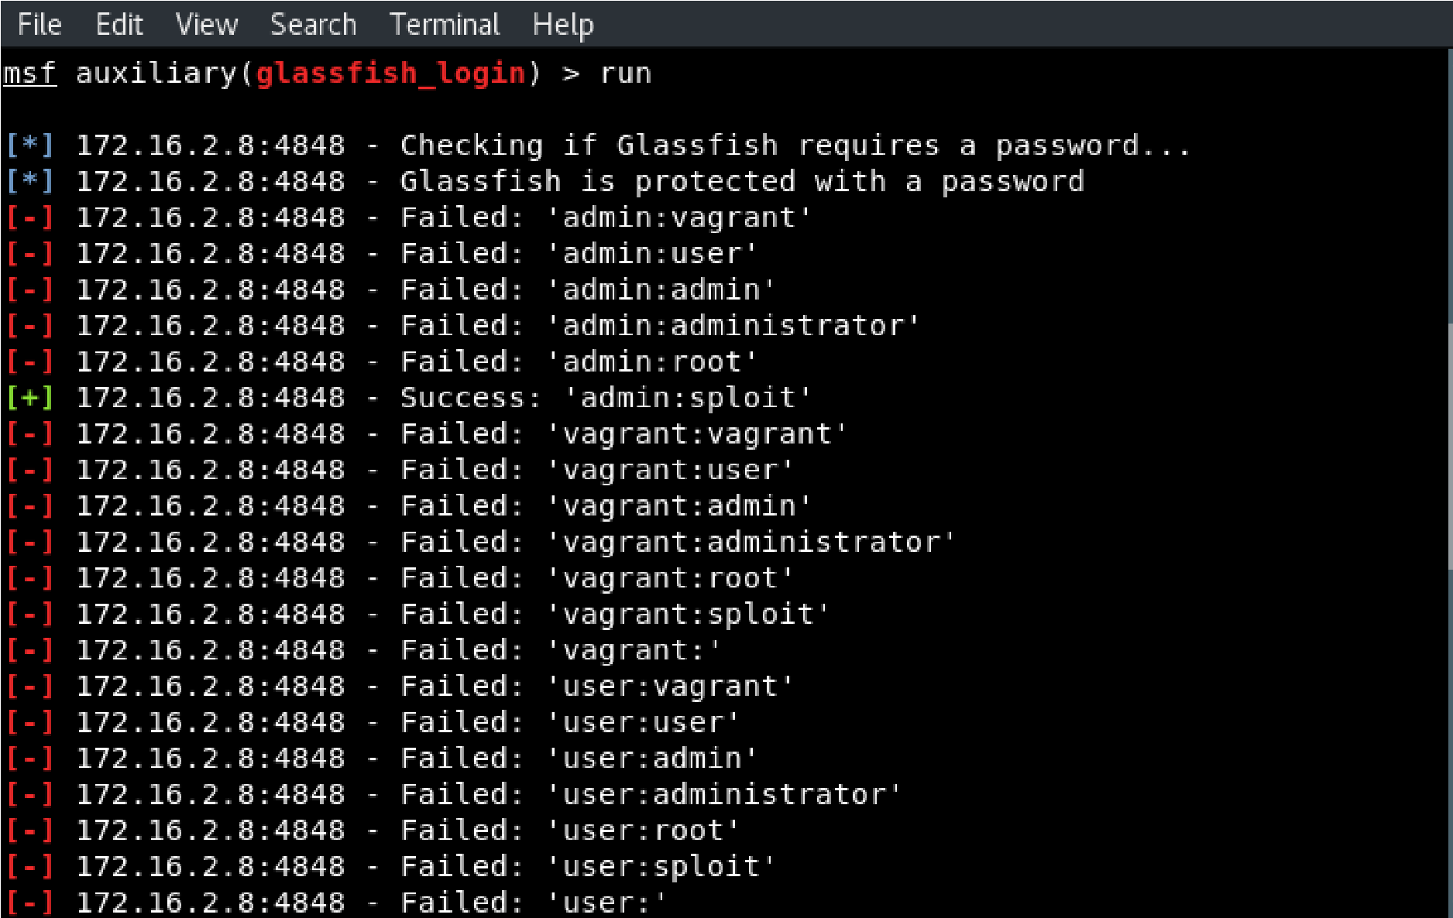

Next, using these credentials, we successfully exploited the vulnerability

in Glassfish to get remote

code execution and obtain a

shell with SYSTEM

privileges:

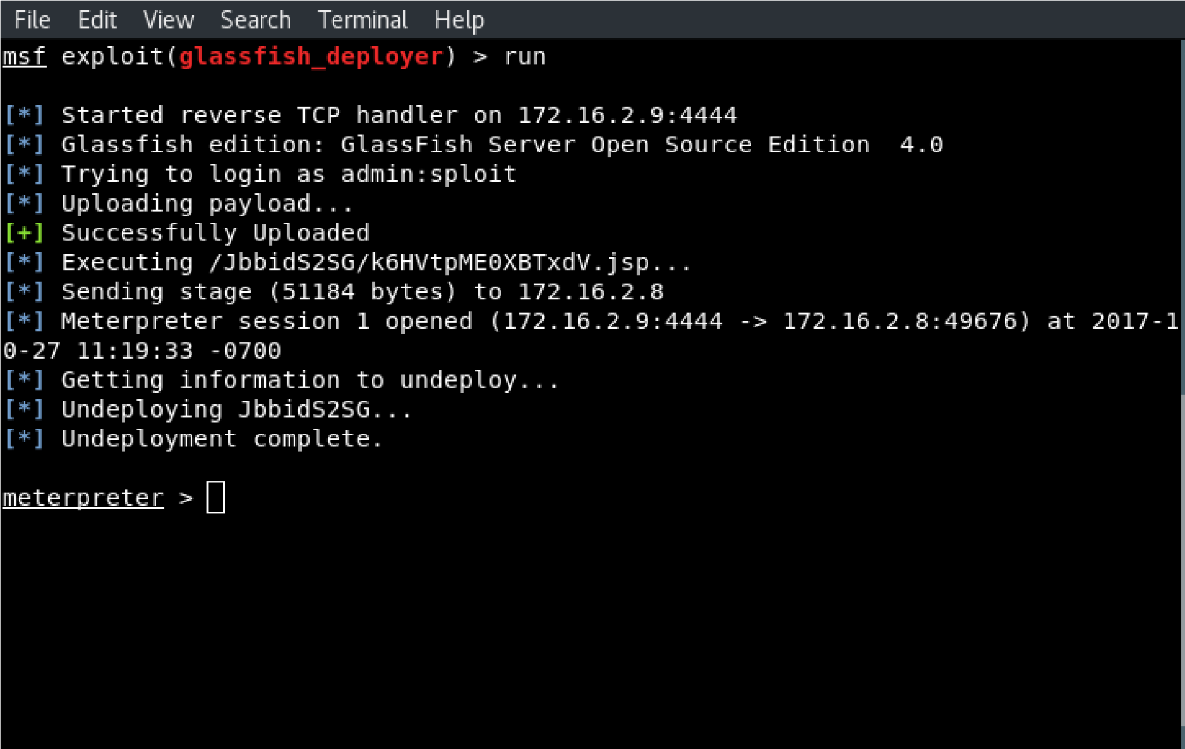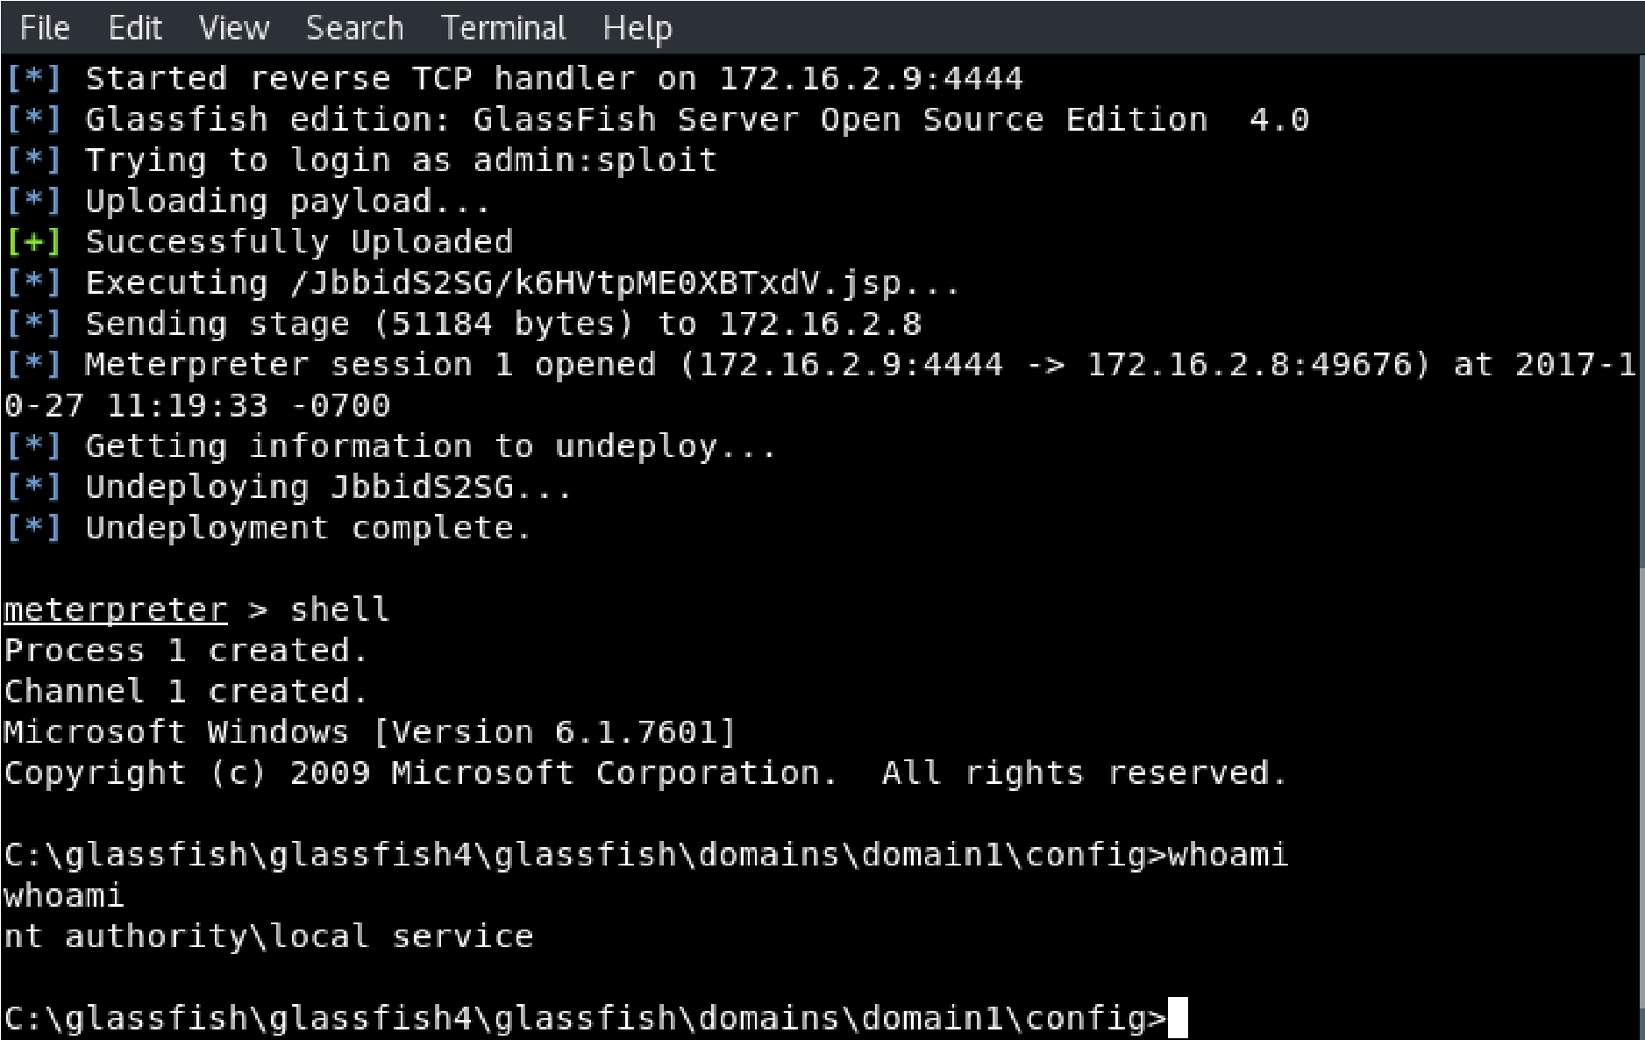

|  |
| --- |
|  |

### Impact

|  |  |
| --- | --- |
| **CVSS Score** | **10.0** |

**Confidentiality Impact:** Complete (There is total information disclosure, resulting in all system files being revealed.)

**Integrity Impact:** Complete (There is a total compromise of system integrity. There is a complete loss of system protection, resulting in the entire system being compromised.)

**Availability Impact:** Complete (There is a total shutdown of the affected resource. The attacker can render the resource completely unavailable.)

**Access Complexity:** Low (Specialized access conditions or extenuating circumstances do not exist.

Very little knowledge or skill is required to exploit.)

**Authentication:** Not required (Authentication is not required to exploit the vulnerability.)

### Recommendations

Ensure that the credentials protecting the Glassfish instance are of suitable complexity to prevent brute force attacks. In addition, Secure Admin can be disabled on the instance to prevent remote access to the DAS in order to mitigate this vulnerability.

### References

<https://cvedetails.com/cve/CVE-2011-0807/>

<https://www.oracle.com/technetwork/topics/security/cpuapr2011-301950.html>

|  |  |
| --- | --- |
| **2. Apache Struts REST Plugin with Dynamic Method Invocation Remote Code Execution** | |
| **Risk** | **HIGH** |
| **Locations(s)** | 172.16.2.8:8282 |
| **Description** | |

Apache Struts 2.3.20.x before 2.3.20.3, 2.3.24.x before 2.3.24.3, and 2.3.28.x before 2.3.28.1, when Dynamic Method Invocation is enabled, allow remote attackers to execute arbitrary code via vectors related to an ! (exclamation mark) operator to the REST Plugin.

A Metasploit module exists which can be used to exploit this vulnerability.

### Observations

Using the exploit/multi/http/struts_dmi_rest_exec Metasploit module, we successfully exploited the Apache Struts vulnerability to get remote code execution and obtain a shell with SYSTEM privileges:

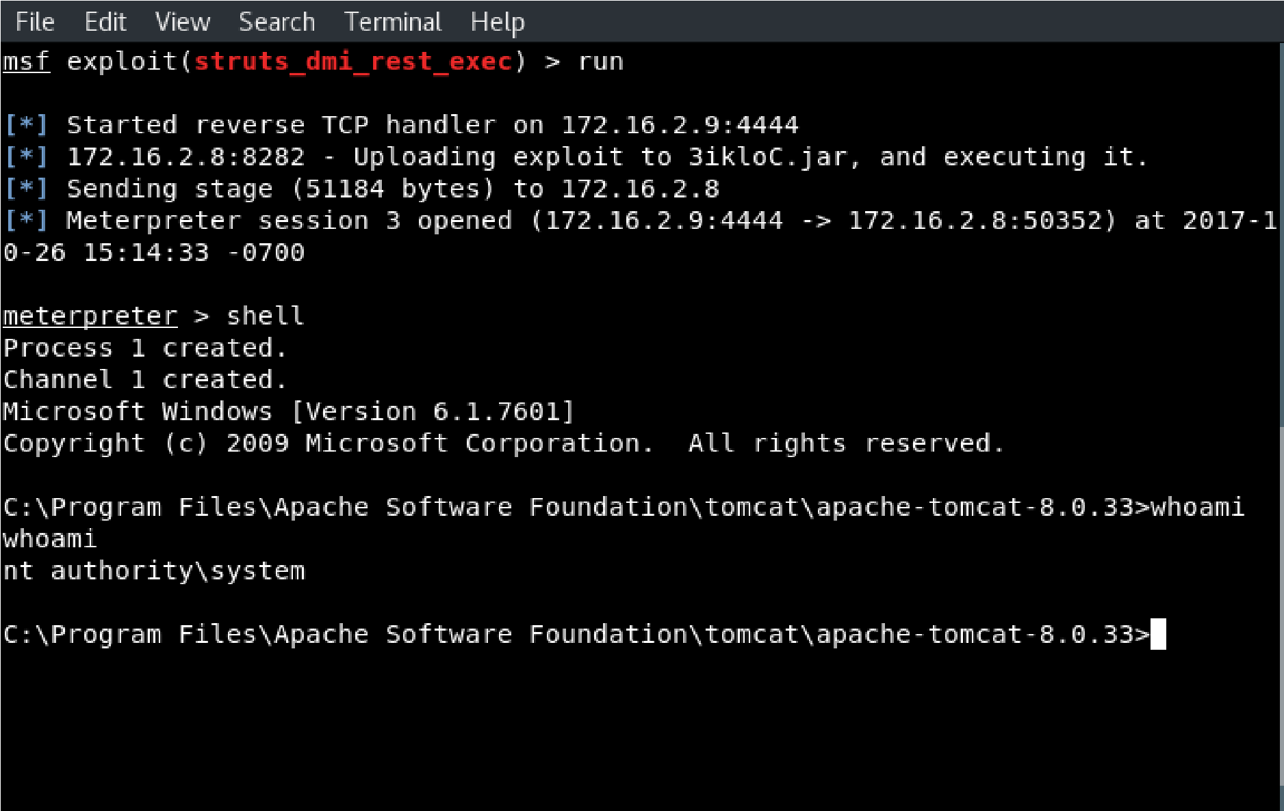

**Impact**

### CVSS Score: 7.5

**Confidentiality Impact:** Partial (There is considerable informational disclosure.)

**Integrity Impact:** Partial (Modification of some system files or information is possible, but the attacker does not have control over what can be modified, or the scope of what the attacker can affect is limited.)

**Availability Impact:** Partial (There is reduced performance or interruptions in resource availability.)

**Access Complexity:** Low (Specialized access conditions or extenuating circumstances do not exist.

Very little knowledge or skill is required to exploit.)

**Authentication:** Not required (Authentication is not required to exploit the vulnerability.)

**Vulnerability Type(s):** Execute Code

### Recommendations

Disable Dynamic Method Invocation if possible. Alternatively upgrade to Struts 2.3.20.3, Struts

2.3.24.3 or Struts 2.3.28.1.

### References

<https://www.cvedetails.com/cve/CVE-2016-3087/> <https://cwiki.apache.org/confluence/display/WW/S2-033><http://www.securityfocus.com/bid/90960>

|  |  |
| --- | --- |
| **3. Unathenticated WebDAV Upload** | |
| **Risk** | **MEDIUM** |
| **Locations(s)** | 172.16.2.8:8585 |
| **Description** | |

The target host has WebDAV enabled, and does not require authentication to upload files to the server.

### Observations

WE were able to upload a PHP reverse shell to the server and execute it, which granted us shell access to the target host:

**Impact**

### CVSS Score: 7.5

**Confidentiality Impact:** Partial (There is considerable informational disclosure.)

**Integrity Impact:** Partial (Modification of some system files or information is possible, but the attacker does not have control over what can be modified, or the scope of what the attacker can affect is limited.)

**Availability Impact:** Partial (There is reduced performance or interruptions in resource availability.)

**Access Complexity:** Low (Specialized access conditions or extenuating circumstances do not exist.

Very little knowledge or skill is required to exploit.)

**Authentication:** Not required (Authentication is not required to exploit the vulnerability.)

**Vulnerability Type(s):** Execute Code

**Recommendations**

Require authentication to use the server’s WebDAV functionality.

### References

<https://www.owasp.org/index.php/Unrestricted_File_Upload>

|  |  |
| --- | --- |
| **4. DistCC Daemon Command Execution** | |
| **Risk** | **CRITICAL** |
| **Locations(s)** | 172.16.2.3:3632 |
| **Description** | |

distcc 2.x, as used in XCode 1.5 and others, when not configured to restrict access to the server port, allows remote attackers to execute arbitrary commands via compilation jobs, which are executed by the server without authorization checks.

A Metasploit module exists to exploit this vulnerability.

### Observations

Using the

exploit/unix/misc/distcc_exec

Metasploit module, we were able to

gain a command shell with root privileges on the target host:

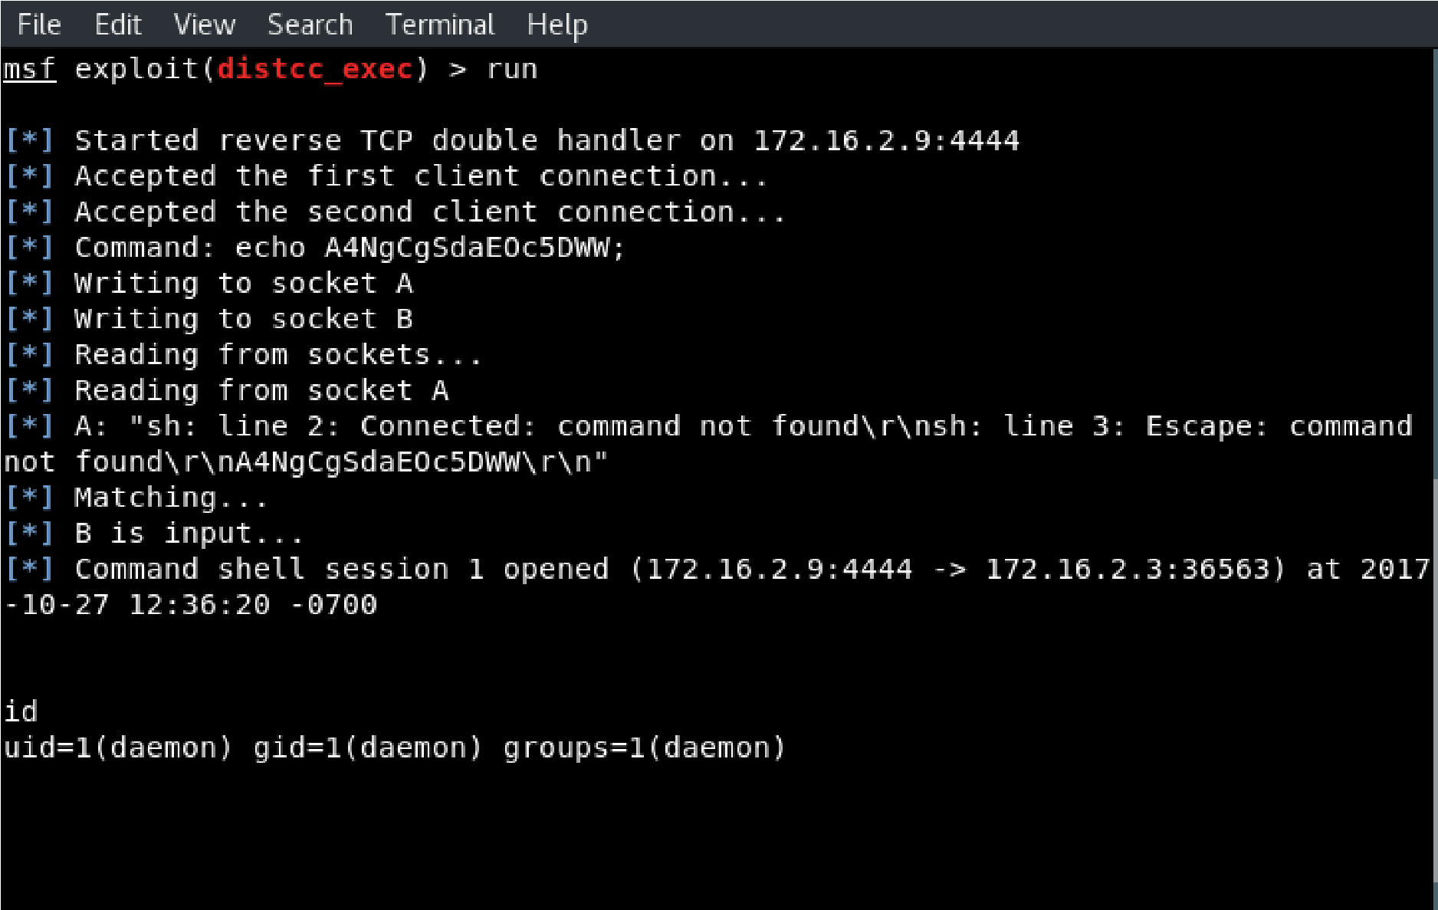

### Impact

**CVSS Score: 9.3**

**Confidentiality Impact:** Complete (There is total information disclosure, resulting in all system files being revealed.)

**Integrity Impact:** Complete (There is a total compromise of system integrity. There is a complete loss of system protection, resulting in the entire system being compromised.)

**Availability Impact:** Complete (There is a total shutdown of the affected resource. The attacker can render the resource completely unavailable.)

**Access Complexity:** Medium (The access conditions are somewhat specialized. Some preconditions must be satisfied to exploit)

**Authentication:** Not required (Authentication is not required to exploit the vulnerability.)

**Gained Access:** Admin

**Vulnerability Type(s):** Execute Code

### Recommendations

Restrict access to the distccd service on UDP port 3632, or remove this service entirely from the host.

### References

<https://cvedetails.com/cve/CVE-2004-2687/><http://distcc.samba.org/security.html>

|  |  |
| --- | --- |
| **5. Misconfigured “r” Services Vulnerability** | |
| **Risk** | **CRITICAL** |
| **Locations(s)** | 172.16.2.3:512,513,514 |
| **Description** | |

TCP ports 512, 513, and 514 are known as "r" services, and have been misconfigured to allow remote access from any host (a standard ".rhosts + +" situation). An attacker can easily log as root via these services, completely compromising the target host.

### Observations

We used the rlogin utility to gain access to the host with root

privileges:

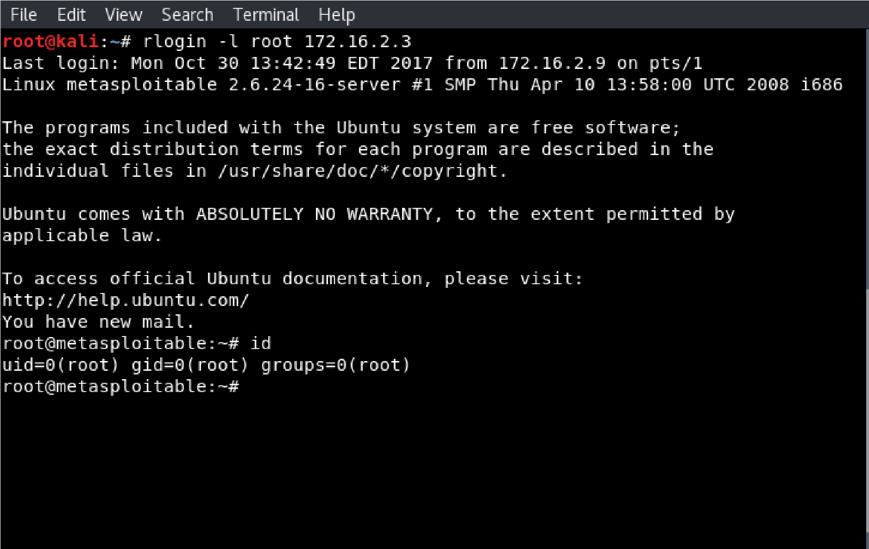

**Impact**

### CVSS Score: 9.3

**Confidentiality Impact:** Complete (There is total information disclosure, resulting in all system files being revealed.)

**Integrity Impact:** Complete (There is a total compromise of system integrity. There is a complete loss of system protection, resulting in the entire system being compromised.)

**Availability Impact:** Complete (There is a total shutdown of the affected resource. The attacker can render the resource completely unavailable.)

**Access Complexity:** Medium (The access conditions are somewhat specialized. Some preconditions must be satisfied to exploit)

**Authentication:** Not required (Authentication is not required to exploit the vulnerability.)

**Gained Access:** Admin

**Vulnerability Type(s):** Execute Code

### Recommendations

Consider the benefits of removing these services from the host. If they are necessary for business functions, then edit the .rhosts file to prevent remote access from any host.

### References

<https://docs.oracle.com/cd/E19455-01/805-7229/remotehowtoaccess-3/index.html>

|  |  |
| --- | --- |
| **6. Samba "username map script" Command Execution** | |
| **Risk** | **MEDIUM** |
| **Locations(s)** | 172.16.2.3:139 |
| **Description** | |

The MS-RPC functionality in smbd in Samba 3.0.0 through 3.0.25rc3 allows remote attackers to execute arbitrary commands via shell metacharacters involving the (1) SamrChangePassword function, when the "username map script" smb.conf option is enabled, and allows remote authenticated users to execute commands via shell metacharacters involving other MS-RPC functions in the (2) remote printer and (3) file share management.

### Observations

We used the exploit/multi/samba/usermap_script Metasploit module to exploit the vulnerable Samba service and obtained a shell with root privileges:

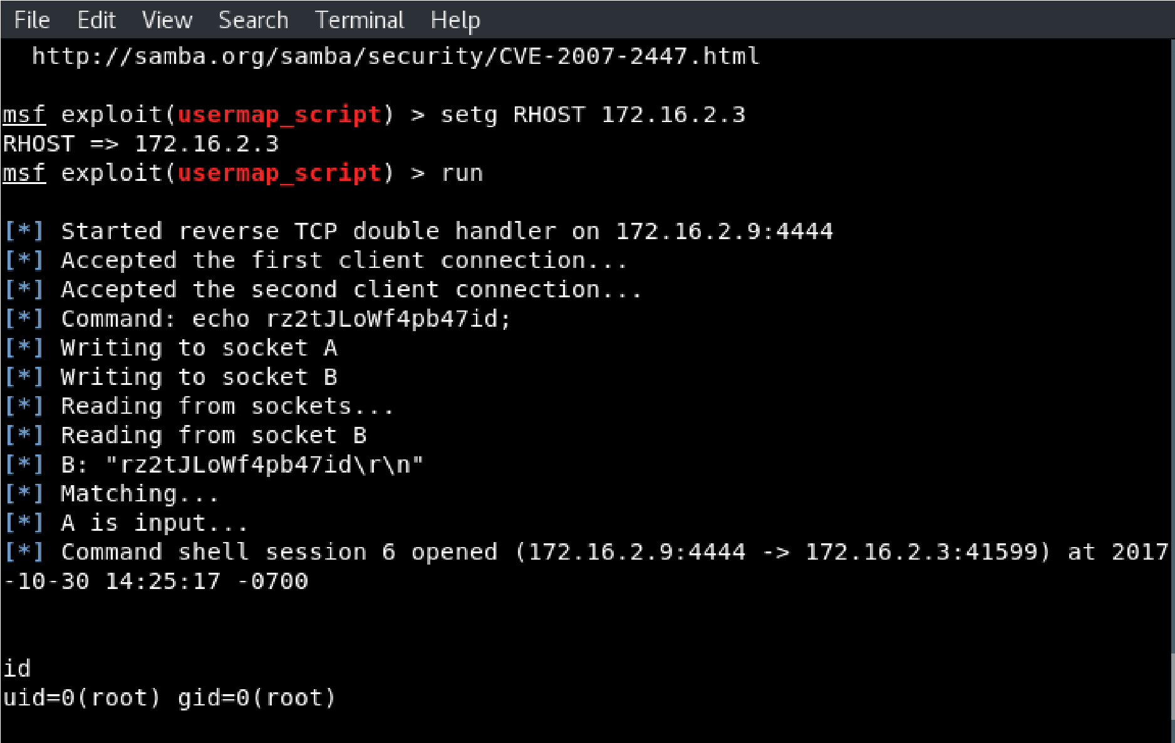

**Impact**

### CVSS Score: 6.0

**Confidentiality Impact:** Partial (There is considerable informational disclosure.)

**Integrity Impact:** Partial (Modification of some system files or information is possible, but the attacker does not have control over what can be modified, or the scope of what the attacker can affect is limited.)

**Availability Impact:** Partial (There is reduced performance or interruptions in resource availability.)

**Access Complexity:** Medium (The access conditions are somewhat specialized. Some preconditions must be satistified to exploit)

**Authentication:** Single system (The vulnerability requires an attacker to be logged into the system

(such as at a command line or via a desktop session or web interface).)

Gained Access: User

**Vulnerability Type(s):** Execute Code

**Recommendations**

Disable the "username map script" option in the smb.conf configuration file.

### References

<https://cvedetails.com/cve/CVE-2007-2447/>

<http://labs.idefense.com/intelligence/vulnerabilities/display.php?id=534>

<http://samba.org/samba/security/CVE-2007-2447.html>

|  |  |
| --- | --- |
| **7. Seattle Lab Mail 5.5 POP3 Buffer Overflow** | |
| **Risk** | **HIGH** |
| **Locations(s)** | 172.16.2.5:110 |
| **Description** | |

Multiple buffer overflows in SLMail 5.1.0.4420 allows remote attackers to execute arbitrary code via (1) a long EHLO argument to slmail.exe, (2) a long XTRN argument to slmail.exe, (3) a long string to POPPASSWD, or (4) a long password to the POP3 server.

A Metasploit module exists to exploit this vulnerability.

### Observations

We used the

exploit/windows/pop3/seattlelab_pass

Metasploit module trigger

a buffer overflow in the Seattle Lab Mail application and obtained a shell

with SYSTEM privileges:

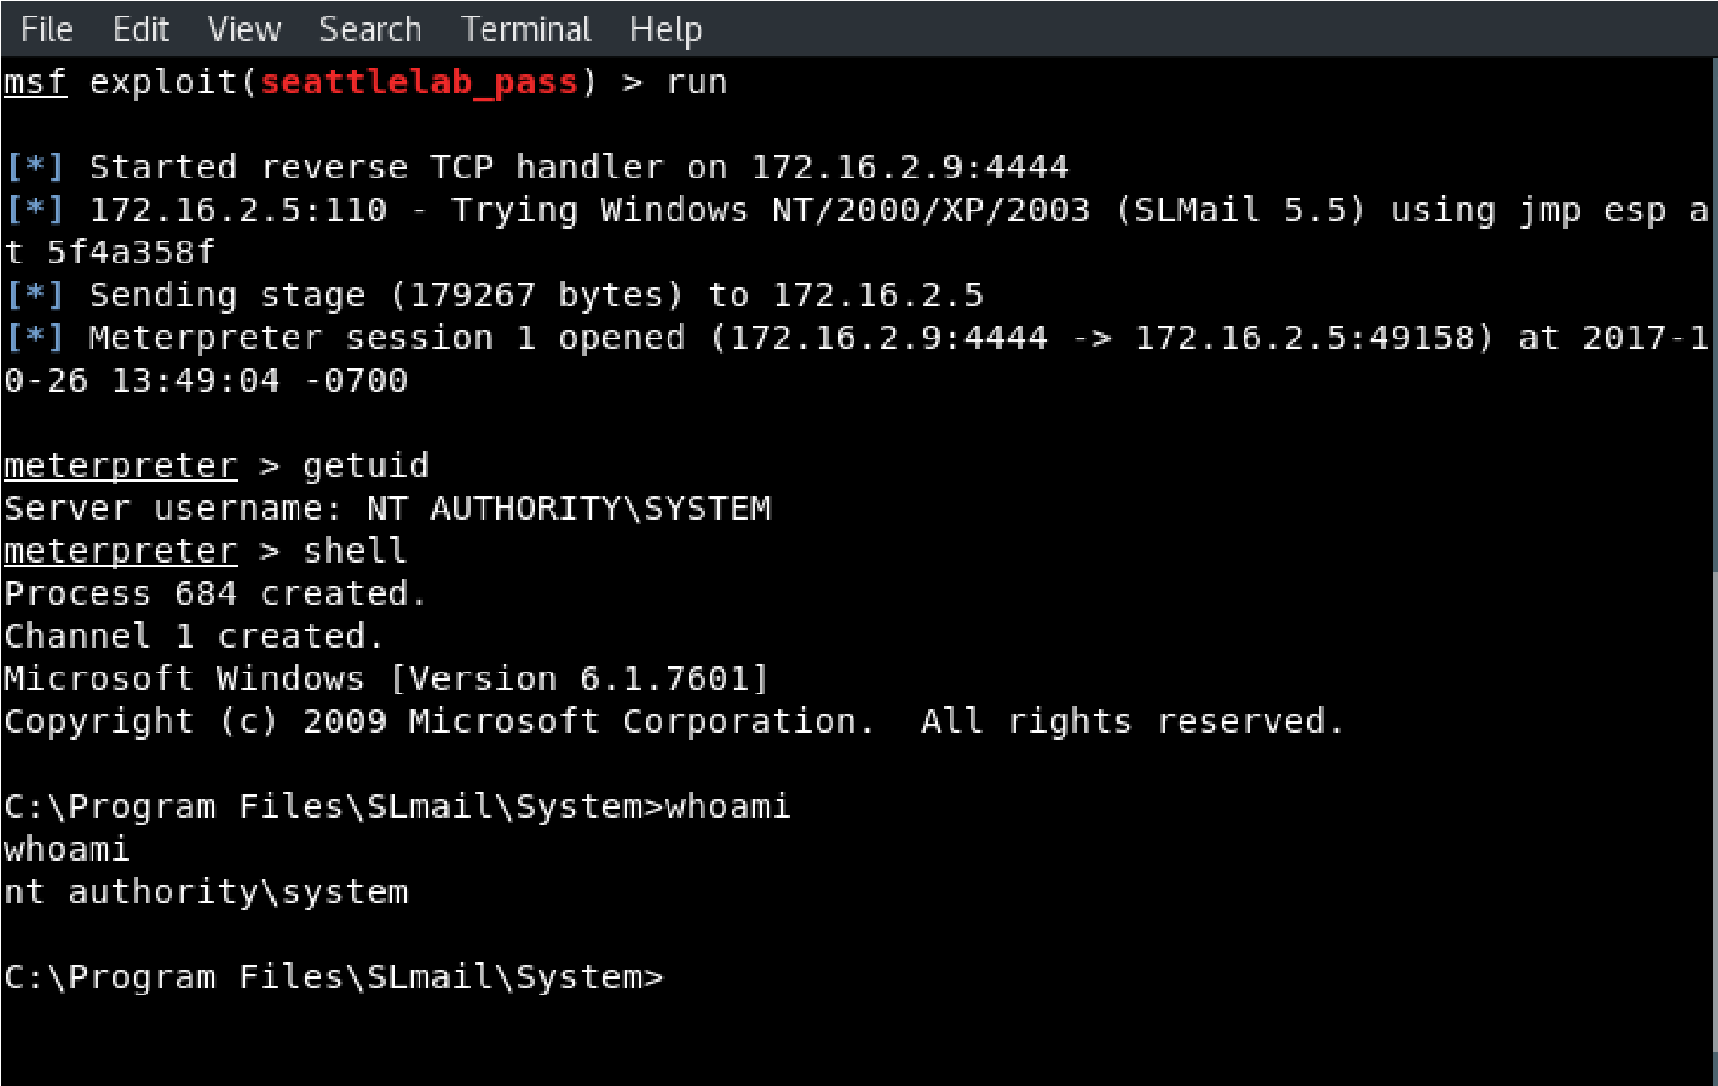

**Impact**

### CVSS Score: 7.5

**Confidentiality Impact:** Partial (There is considerable informational disclosure.)

**Integrity Impact:** Partial (Modification of some system files or information is possible, but the attacker does not have control over what can be modified, or the scope of what the attacker can affect is limited.)

**Availability Impact:** Partial (There is reduced performance or interruptions in resource availability.)

**Access Complexity:** Low (Specialized access conditions or extenuating circumstances do not exist.

Very little knowledge or skill is required to exploit. )

**Authentication:** Not required (Authentication is not required to exploit the vulnerability.)

**Gained Access:** User

**Vulnerability Type(s):** Execute CodeOverflow

### Recommendations

NGSSoftware alerted SLMail to most of these issues in early 2003 and a patch through an upgrade has been released. See [http://www.slmail.com](http://www.slmail.com/) for more details. If upgrading is not an option then NGSSoftware recommends that steps be taken to mitigate the risk by only allowing access to the POPPASSWD and POP3 server from "inside" the firewall. "External" access can be provided allowing clients to connect via an authenticated VPN to the DMZ and then to the POP services from there.

### References

<https://www.cvedetails.com/cve/CVE-2003-0264/><http://www.securityfocus.com/bid/7519>

<https://marc.info/?l=bugtraq&m=105232506011335&w=2>

# WEB APPLICATION FINDINGS

# SCOPE

The scope of the web application testing of the engagement included the Wordpress application located at [http://172.16.2.8:8585/wordpress/.](http://172.16.2.8:8585/wordpress/) The application is a business-critical corporate web site used primarily for scheduling and recording meeting notes.

Testing was performed using industry-standard penetration testing tools and frameworks, including Nmap, WPScan, Wireshark, and Burp Suite.

# WEB APPLICATION RESULTS

|  |  |
| --- | --- |
| **Result Classification** |  |
| **Vulnerabilities Found** | Yes |
| **Exploited – Denial of Service (DoS)** | No |
| **Exploited – Elevation of Privilege (EoP)** | No |
| **Exploited – Remote Code Execution (RCE)** | Yes |
| **Exploit Persistence Achieved** | No |
| **Sensitive Data Exfiltrated** | No |
| **Overall Risk** | **HIGH** |

A vulnerable Wordpress module allowed remote code execution leading to a command shell on the server, and simple scanning also discovered a weak administrator username and password combination, which granted the ability to edit PHP code on the website and gain access to a command shell on the server.

|  |  |  |
| --- | --- | --- |
| **OWASP 2013 Top 10** | | **Result** |
| A1 | Injection |  |
| A2 | Broken Authentication and Session Management |  |
| A3 | Cross-Site Scripting (XSS) |  |
| A4 | Insecure Direct Object References |  |
| A5 | Security Misconfiguration |  |
| A6 | Sensitive Data Exposure |  |
| A7 | Missing Function Level Access Control |  |
| A8 | Cross-Site Request Forgery (CSRF) |  |
| A9 | Using Components with Known Vulnerabilities |  |
| A10 | Unvalidated Redirects and Forwards |  |

- Critical,  - High,  - Medium,  - Low,  - None

# Web Application Detailed Findings

PrimoConnect strongly recommends that the following vulnerabilities be remediated, whether exploited or not, as they represent unnecessary risk to the organization’s overall security posture.

# Vulnerability Summary Table

|  |  |  |  |
| --- | --- | --- | --- |
| **#** | **Vulnerability Summary** | **Risk Level** | **Recommendations** |
| **1** | WordPress Ninja Forms Unauthenticated  File Upload | **HIGH** | Update Ninja Forms to version  2.9.43 or higher |
| **2** | Default and/or weak administrator credentials | **HIGH** | Increase the strength of the password for the “vagrant” administrator account |

# Details

|  |  |
| --- | --- |
| **1. WordPress Ninja Forms Unauthenticated File Upload** | |
| **Risk** | **HIGH** |
| **Locations(s)** | http://172.16.2.8:8585/wordpress/index.php/king-of-hearts |
| **Description** | |

The Ninja Forms plugin before 2.9.42.1 for WordPress allows remote attackers to conduct PHP object injection attacks via crafted serialized values in a POST request.

Two Metasploit modules exists to exploit this vulnerability.

### Observations

The scan output from WPScan alerted us that the web application has a vulnerable version of Ninja Forms installed:

With this information, we used the

exploit/multi/http/wp_ninja_forms_unauthenticated_file_upload

Metasploit

module to gain a shell on the target machine:

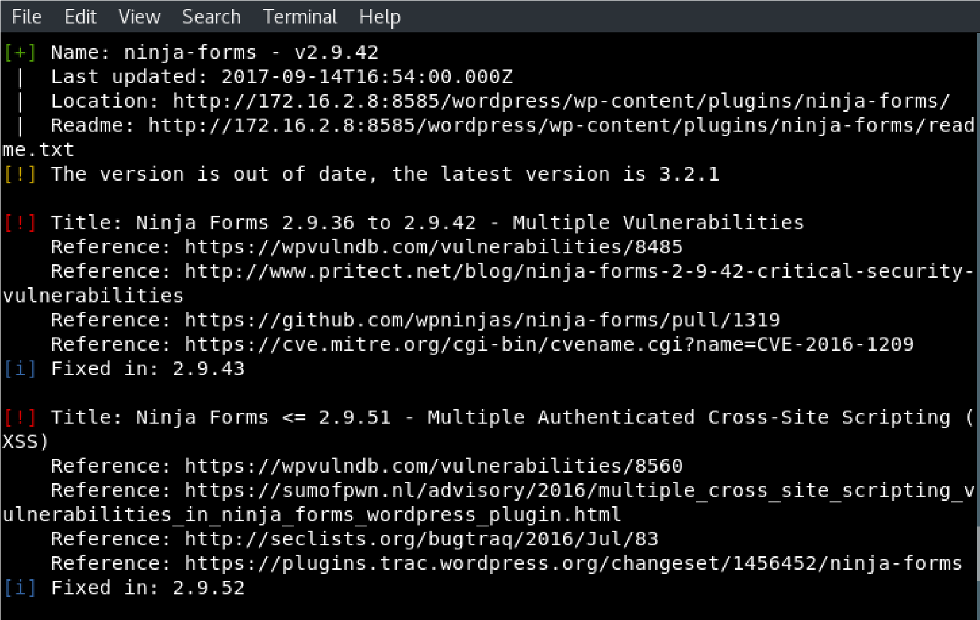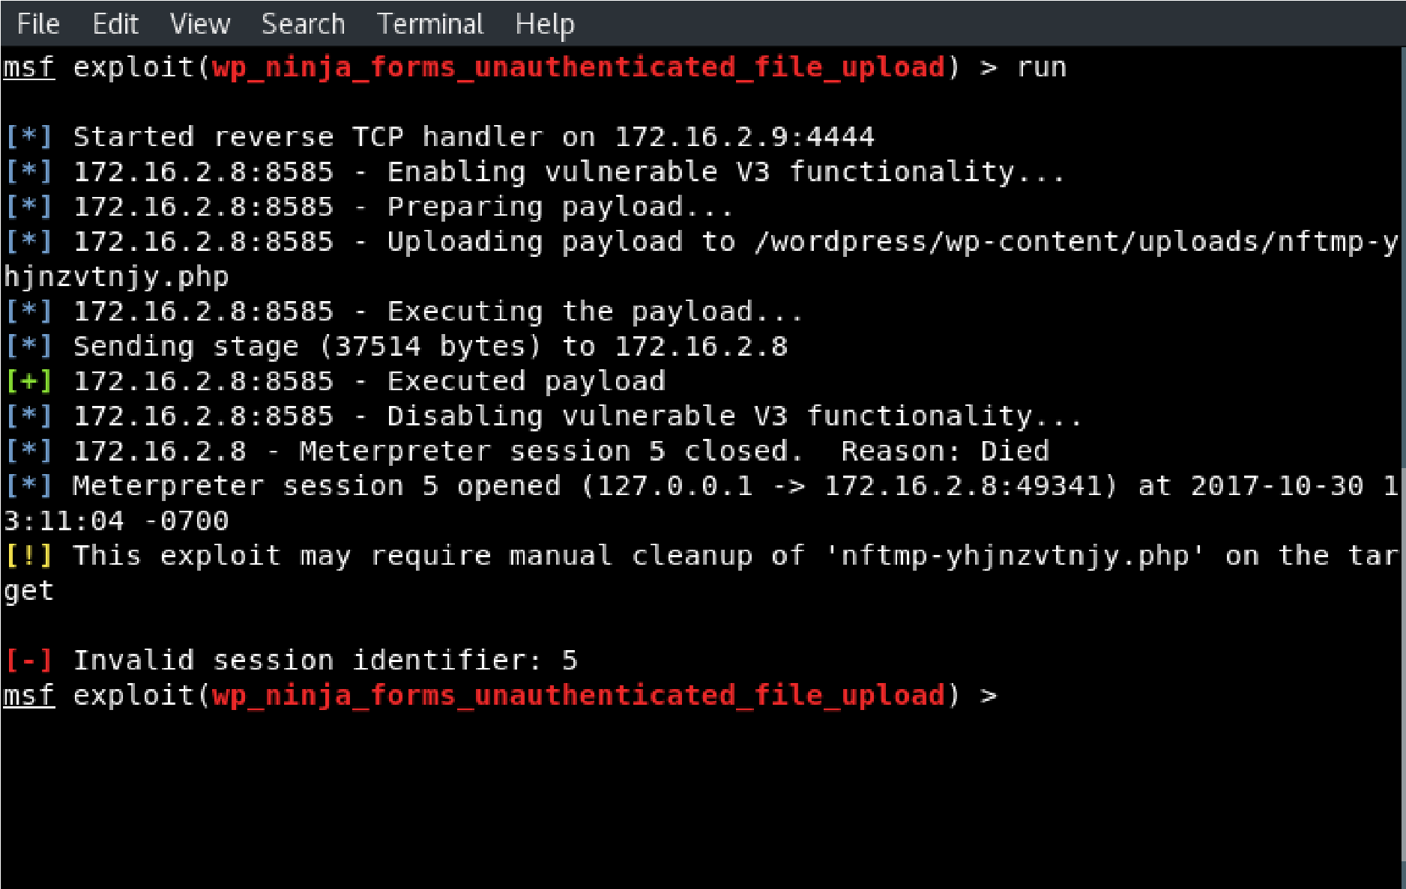

|  |
| --- |
|  |

**Impact**

### CVSS Score: 7.5

**Confidentiality Impact:** Partial (There is considerable informational disclosure.)

**Integrity Impact:** Partial (Modification of some system files or information is possible, but the attacker does not have control over what can be modified, or the scope of what the attacker can affect is limited.)

**Availability Impact:** Partial (There is reduced performance or interruptions in resource availability.)

**Access Complexity:** Low (Specialized access conditions or extenuating circumstances do not exist.

Very little knowledge or skill is required to exploit.)

**Authentication:** Not required (Authentication is not required to exploit the vulnerability.)

### Recommendations

Upgrade Ninja Forms to version 2.9.43 or higher.

**References:**

<https://www.cvedetails.com/cve/CVE-2016-1209/> <https://wpvulndb.com/vulnerabilities/8485>

<http://www.pritect.net/blog/ninja-forms-2-9-42-critical-security-vulnerabilities>

|  |  |
| --- | --- |
| **2. Default and/or Weak Administrator Credentials** | |
| **Risk** | **HIGH** |
| **Locations(s)** | http://172.16.2.8:8585/wordpress/ |
| **Description** | |

The target web application utilizes weak administration credentials. The username “vagrant” and the password “vagrant” allow access to the web application administration panel, which can lead to code execution on the server.

### Observations

The scan output from WPScan alerted us that the web application uses a weak password to protect the “vagrant” administrator account:

Using this password, we logged into the administration panel and injected

PHP code into the header.php file:

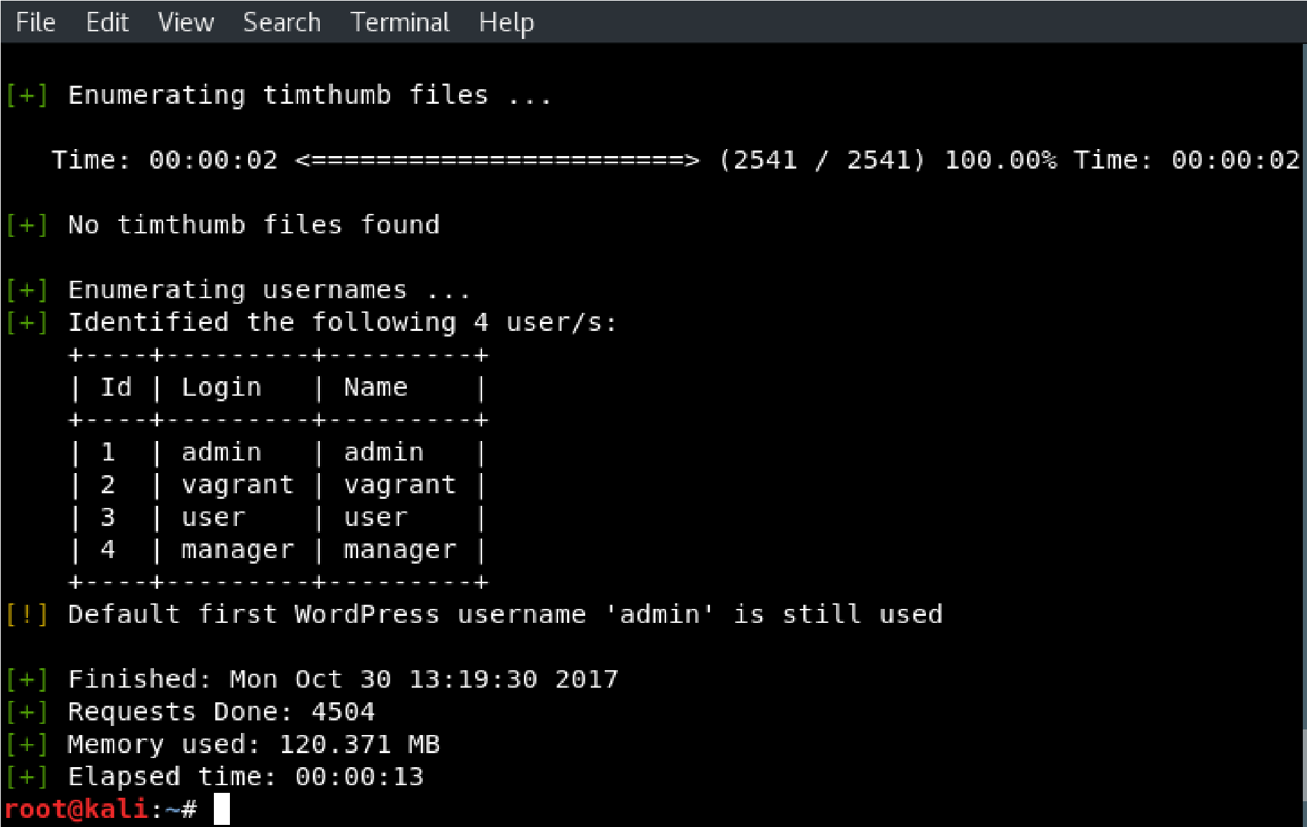

Once we sa

ved these edits, we navigated to the web application once more,

which triggered our PHP reverse shell, and gave us shell access to the

server:

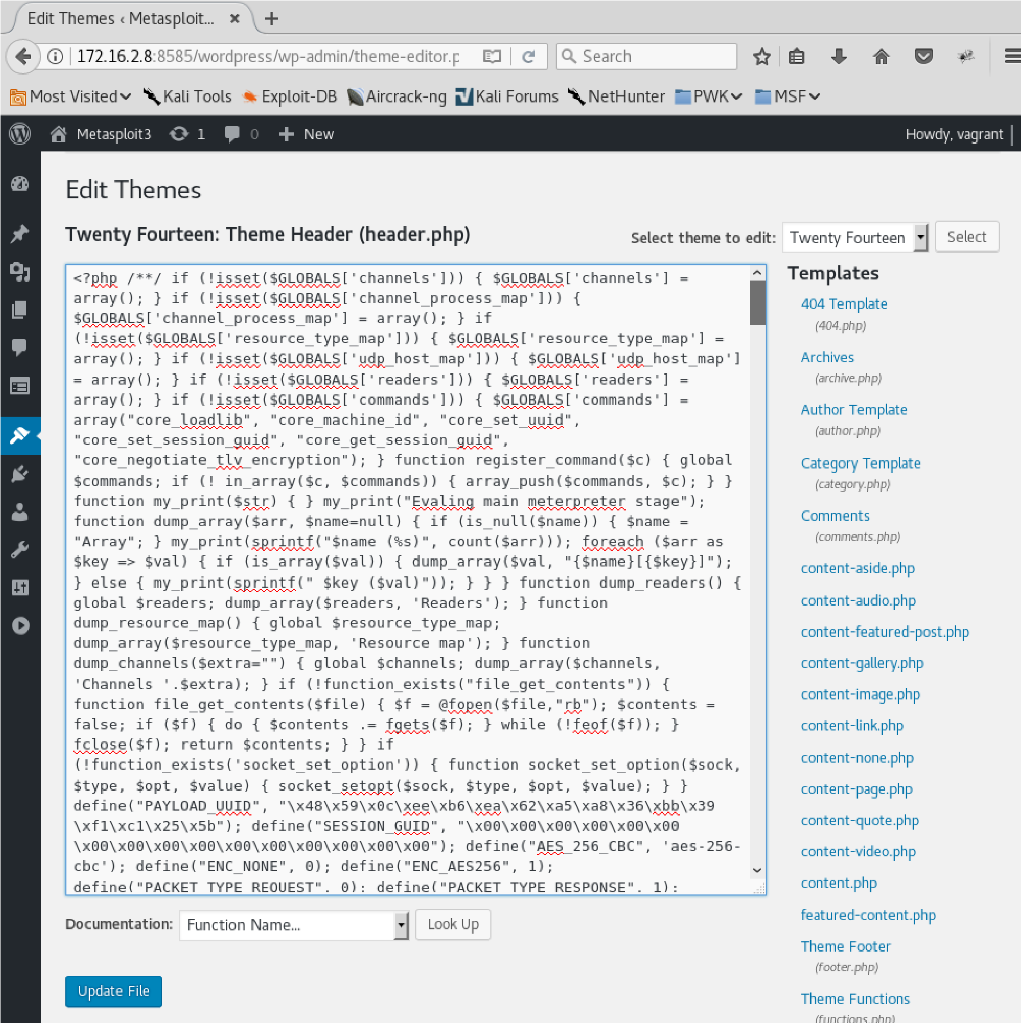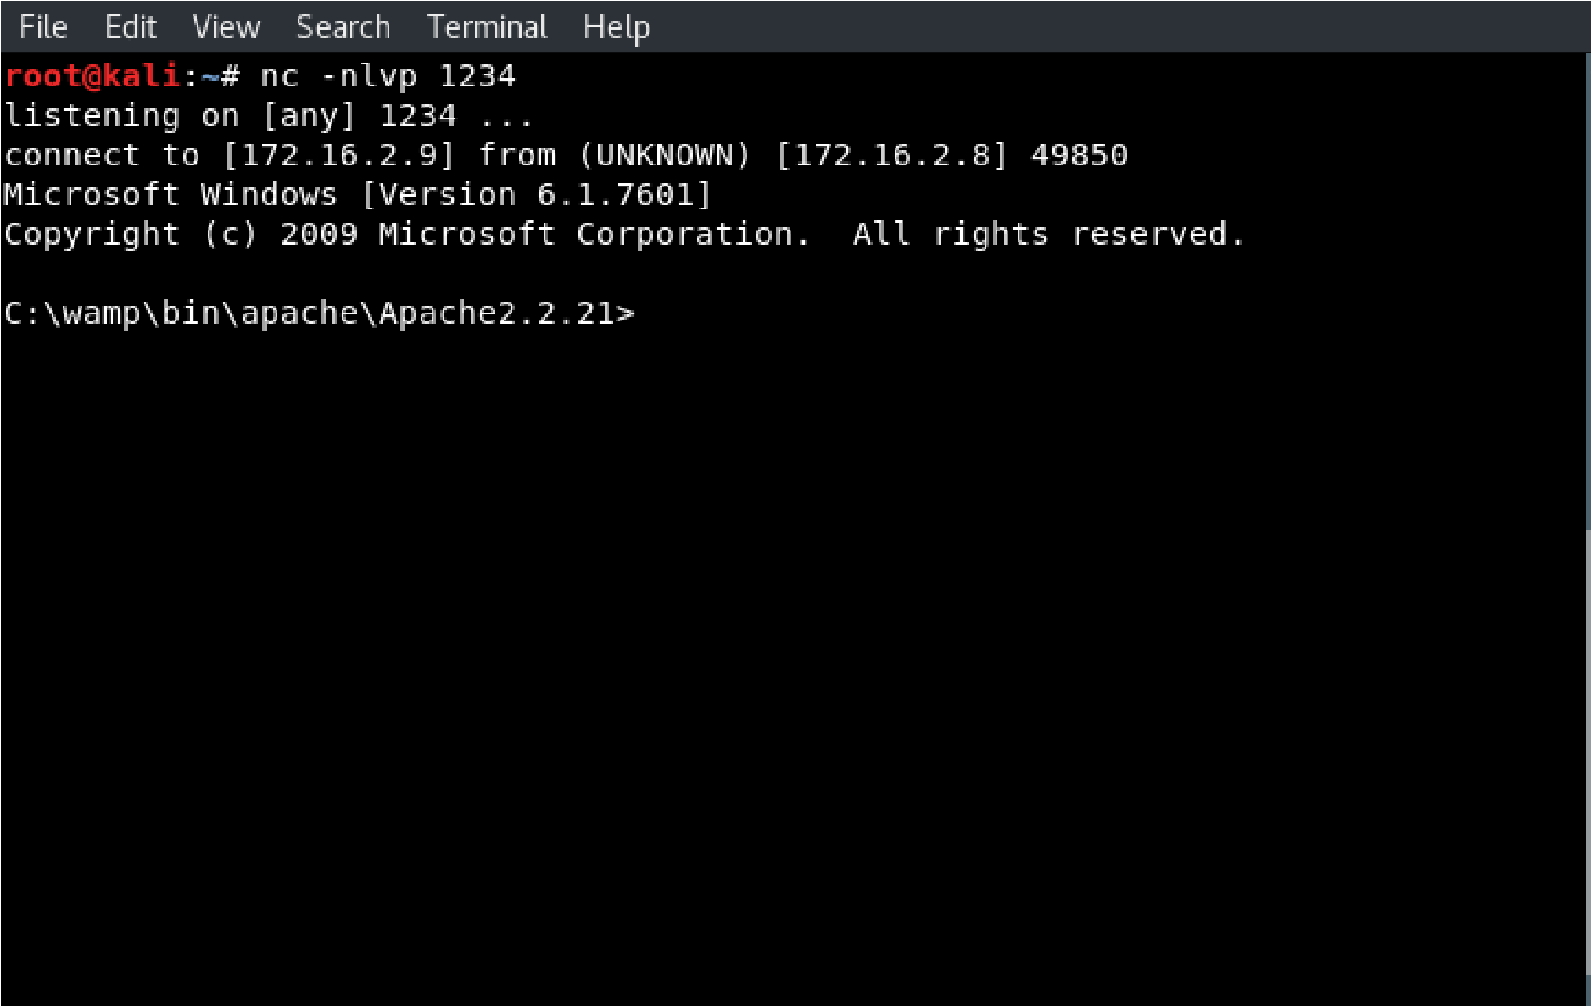

**Impact**

### CVSS Score: 7.5

**Confidentiality Impact:** Partial (There is considerable informational disclosure.)

**Integrity Impact:** Partial (Modification of some system files or information is possible, but the attacker does not have control over what can be modified, or the scope of what the attacker can affect is limited.)

**Availability Impact:** Partial (There is reduced performance or interruptions in resource availability.)

**Access Complexity:** Low (Specialized access conditions or extenuating circumstances do not exist.

Very little knowledge or skill is required to exploit.)

**Authentication:** Required (Authentication is required to exploit the vulnerability.)

### Recommendations

Use stronger passwords to protect the administration panel of the website, and never set the password to be the same as the user account for which it is associated.

**References:**

<https://www.cvedetails.com/cve/CVE-2016-1209/> <https://wpvulndb.com/vulnerabilities/8485>

<http://www.pritect.net/blog/ninja-forms-2-9-42-critical-security-vulnerabilities>

# WIRELESS NETWORK FINDINGS

# SCOPE

The following Wireless Network SSIDs were within the scope of this engagement:

|  |
| --- |
| **Target IP Addresses** |
| **SCcast** |
| **SampleCorp** |
| **SCGuest** |

Testing for this phase of the engagement was performed using industry-standard penetration testing tools and frameworks, including Aircrack-ng, Reaver, Asleap, and Arpspoof.

# WIRELESS NETWORK RESULTS

# Access via Wi-Fi Penetration Testing Device

A penetration testing appliance utilizing a reverse VPN tunnel was connected to the customer environment and used as a remote platform for wireless testing.

# Wireless Network Reconnaissance

The remote penetration testing device was placed within the SampleCorp network. The wireless network audit began with a full sweep of the 2.4GHz wireless frequencies, where numerous busy networks were found.

We located 5 SSIDs likely to be owned by the client, and being served by their wireless equipment across 2.4GHz center channels 1, 6 and 11; Sccast, SampleCorp, SCGuest, and 2 hidden networks.

It was possible to confidently enumerate the overall wireless attack surface of the wireless network due to the sequential BSSID numbering (00:3A:7D:D1:34:60 to 64) on the various SSIDs as shown below:

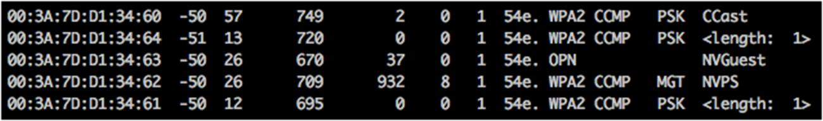

Networks showing as ‘<length: 1>’ are hidden SSIDs. It should be noted that while hidden SSIDs will not show up on a wireless scan with a standard laptop or mobile, they offer no practical level of security. On a hidden network, the SSID is not beaconed (broadcasted) out, however a client connecting to the network will specifically probe for (request) the hidden network before the access point responds. At this point, any attacker monitoring the open wireless spectrum will gain knowledge of the SSID in use.

**Sccast** is a WPA2 password protected network. Two hidden networks also protected via WPA2 were located. All three of these networks utilize the industry standard WPA2/AES.

**Scguest** is an open public network.

**SampleCorp** is an Enterprise WPA2 protected network, utilizing a backend RADIUS authentication mechanism, as is also standard in enterprise settings.

None of the networks identified within scope had WPS or other vulnerable extensions enabled.

The network equipment was discovered to be provided by Cisco via the manufacturer part of the BSSIDs broadcast by the access points (00:3A:7D, 00:42:68)

# Wireless Network Penetration Testing

1. **Hidden SSIDs**

We did not identify any clients connecting to the hidden SSIDs during the audit period, and therefore it was not possible to unmask them. As soon as a client would have connected to a hidden network, the SSID would have become visible.

1. **Sccast**

Sccast is a WPA2-PSK/CCMP network. It uses the industry standard AES encryption protocol, and a preshared key for network access.

Through sniffing the network while forcing an existing client off the network, we were able to capture a WPA2 handshake. Capturing the handshake in itself does not bestow any level of network access, however it is necessary before an attempted brute force attack.

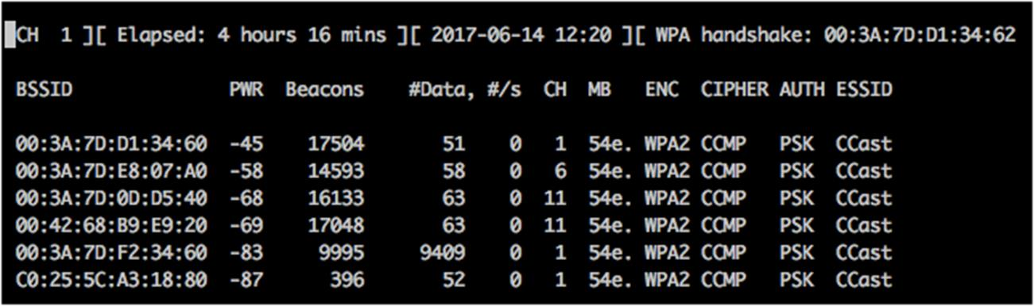

We then proceeded to attempt a brute force attack using the captured handshake. The password was not found within a dictionary of over 250,000 common passwords, and we were unable to gain access to the network.

1. **SampleCorp**

An interception and attack were launched against SAMPLECORP in a similar fashion as Sccast above. The key difference being that SAMPLECORP uses an Enterprise/RADIUS backend, whilst Sccast does not.

Once we were able to capture the authentication handshake, we examined it within `Wireshark’ in order to extract the enterprise parameters. These were passed to the tool `asleap’ to be tested against a dictionary of over 250,000 common passwords. This attack was unsuccessful.

**3. SCguest**

SCguest is an open wireless network.

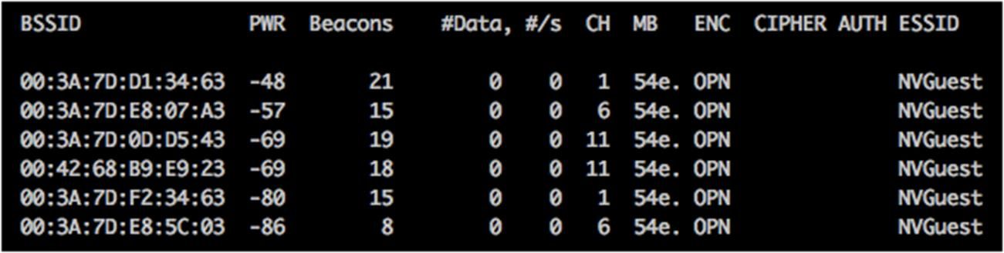

We were able to connect and request network details via DHCP. 192.0.2.1 (0:3a:7d:d1:34:60) offered us an IP address of 192.168.30.250, with the following options set:

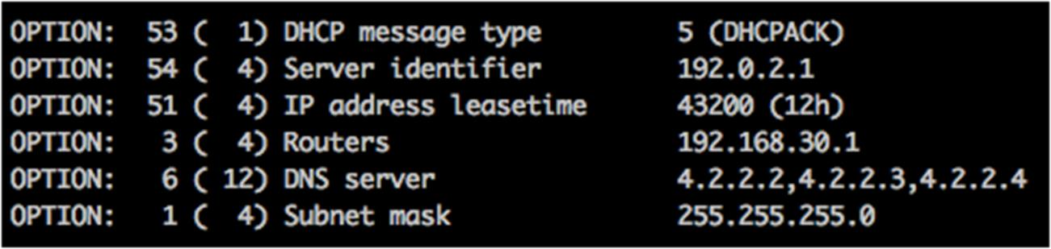

Once on the network, we were either isolated from other clients, or no other clients were present. This was verified through extensive ping and ARP scanning of the /24 guest range.

It should be noted that traffic transmitted via an open wireless network is entirely insecure and subject to interception and modification.

Based on the Cisco architecture, a scan was made for CDP traffic which would have disclosed further information about the network. CDP was not found to be running across the public guest network, and VLAN hopping was unsuccessful.

# MOBILE APPLICATIONS FINDINGS

# SCOPE

PrimoConnect was tasked to perform penetration testing against an Android mobile application developed and used internally by SampleCorp, called Sieve. This app serves as a password manager, allowing employees to save passwords to their Android devices, with the intent of keeping them securely encrypted until use.

Tools used: Drozer, Adb

# APPLICATION RESULTS

|  |  |
| --- | --- |
| **Result Classification** |  |
| **Vulnerabilities Found** | Yes |
| **Exploited – Denial of Service (DoS)** | No |
| **Exploited – Elevation of Privilege (EoP)** | No |
| **Exploited – Remote Code Execution (RCE)** | No |
| **Exploit Persistence Achieved** | No |
| **Sensitive Data Exfiltrated** | Yes |
| **Overall Risk** | **HIGH** |

There were three vulnerabilities found in the mobile application’s database-backed content providers, which were successfully exploited to obtain user’s plaintext usernames, email addresses, master passwords, and saved passwords.

# Application Detailed Findings

PrimoConnect strongly recommends halting use of the app until it is either re-engineered in a more secure manner, or a suitable replacement is found. If management decides to continue using the app, we strongly recommend that the following vulnerabilities are dealt with as soon as possible, in order to secure the personal information of employees using the app.

# Vulnerability Summary Table

|  |  |  |  |
| --- | --- | --- | --- |
| **#** | **Vulnerability Summary** | **Risk Level** | **Recommendations** |
| **1** | Content Providers Data Leakage | **MEDIUM** | Ensure that the all content providers require strict permission for interaction. |
| **2** | Content Providers SQL Injection | **HIGH** | Ensure that the all content providers require strict permission for interaction. |
| **3** | Content Providers Directory Traversal | **HIGH** | Disable content provider access to the device’s underlying filesystem. |

# Details

|  |  |
| --- | --- |
| **1. Database-Backed Content Providers (Data Leakage)** | |
| **Risk** | **MEDIUM** |
| **Locations(s)** | content://com.mwr.example.sieve.DBContentProvider/Keys/ content://com.mwr.example.sieve.DBContentProvider/Passwords content://com.mwr.example.sieve.DBContentProvider/Passwords/ |
| **Description** | |

Android apps tend to give away hints about the content URIs. We were able to create a list of accessible content URIs, some of which contained sensitive user information, and eventually access them without any authentication.

### Observations

Initial scans confirmed

that

many of the application’s

content providers

do not require any particular permission to interact with them, except for

the /Key

s path in the DBContentProvider:

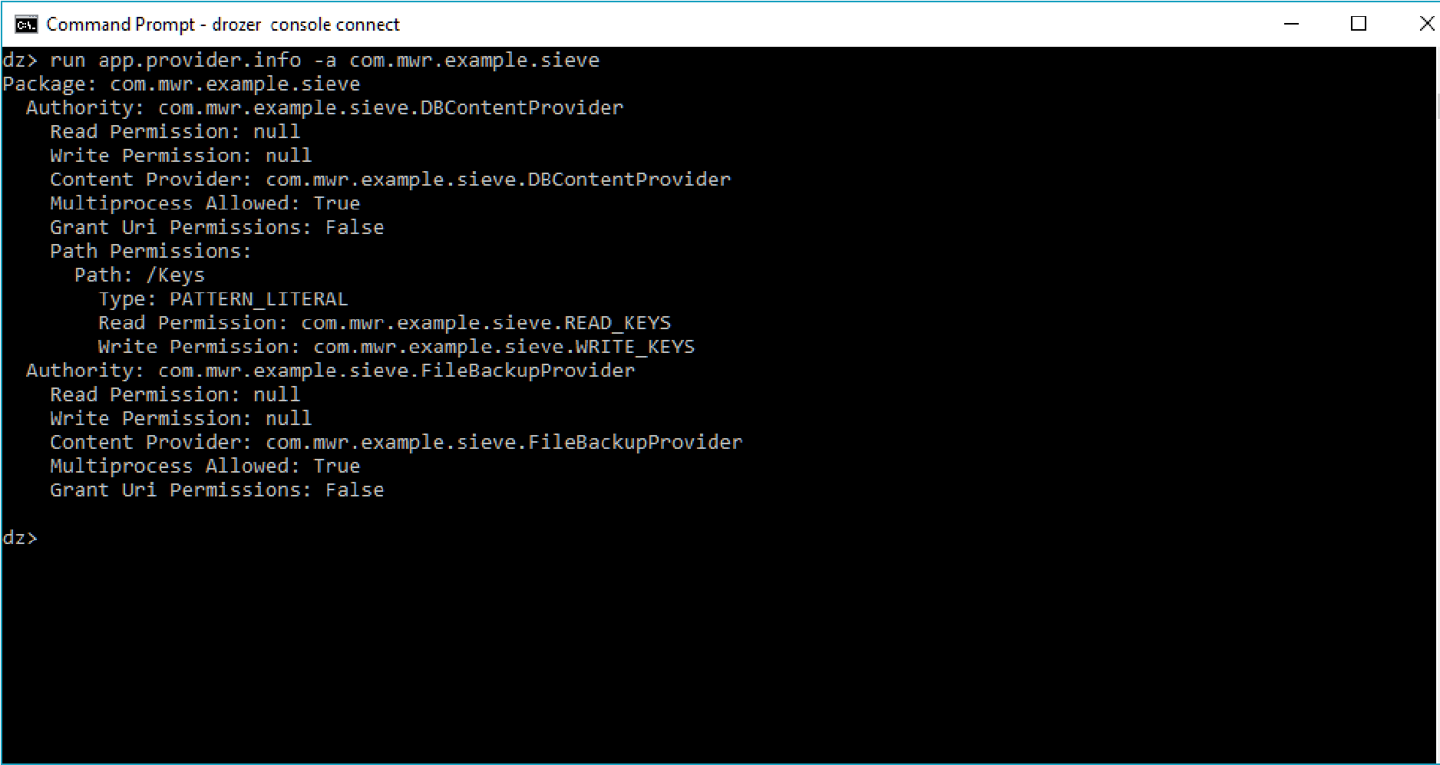

drozer provides a scanner module that brings together various ways to

guess paths

and divine a list of accessible

cont

ent URIs:

This allows use to use other drozer

modules to retrieve information from

those content URIs, or even modify the data in the database:

Ultimately, we were able to defeat the app’s security and retrieve a list

of

information from the app:

service:

facebook.com

username:

bob1

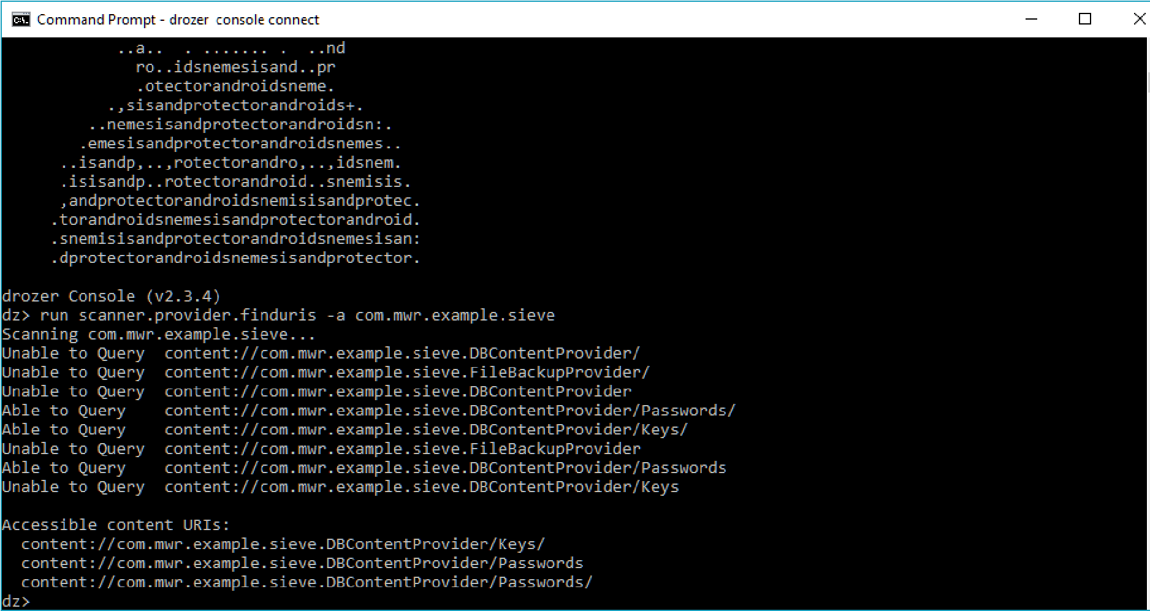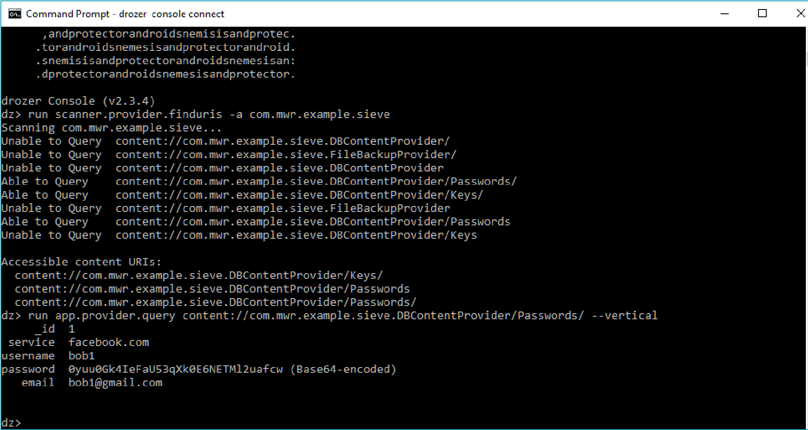

|  |
| --- |
| password: 0yuu0Gk4IeFaU53qXk0E6NETMl2uafcw (Base64-encoded) email: bob1@gmail.com    The user’s password is still Base64 encoded however, but decryption of the password is an easy task. |

**Impact**

Attackers can bypass the application’s security and retrieve sensitive user information from the app.

### Recommendations

Ensure that the all content providers require strict permission to interact for interaction.

|  |  |
| --- | --- |
| **2. Database-Backed Content Providers (SQL Injection)** | |
| **Risk** | **HIGH** |
| **Locations(s)** | content://com.mwr.example.sieve.DBContentProvider/Passwords content://com.mwr.example.sieve.DBContentProvider/Passwords/ |
| **Description** | |

The Android platform promotes the use of SQLite databases for storing user data. Since these databases use SQL, it should come as no surprise that they can be vulnerable to SQL injection.

### Observations

We tested for

SQL injection by manipulating the projection and selection

f

ields that are passed to the

content provider:

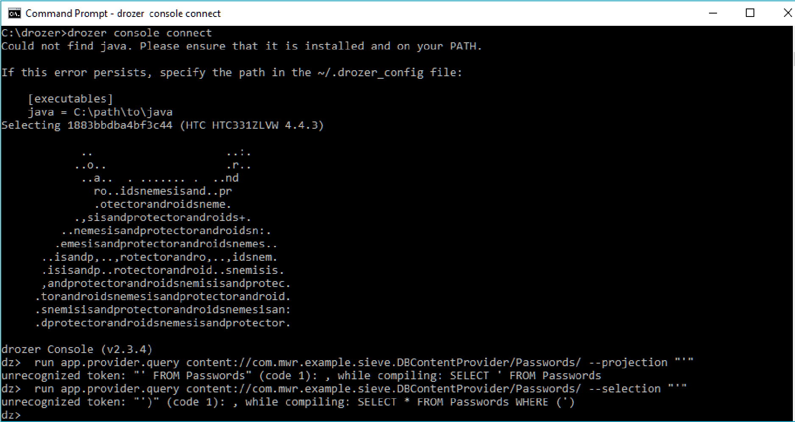

Android

returns a very verbose error message, showing the entire query

that it tried to execute. This allowed us to fully exploit the SQL

Injection vulnerability to list all the tables in the database, and to

query otherwise protected tables, giving us the user’s

master password and

PIN:

Password:

insecure123456789

Pin:

1234

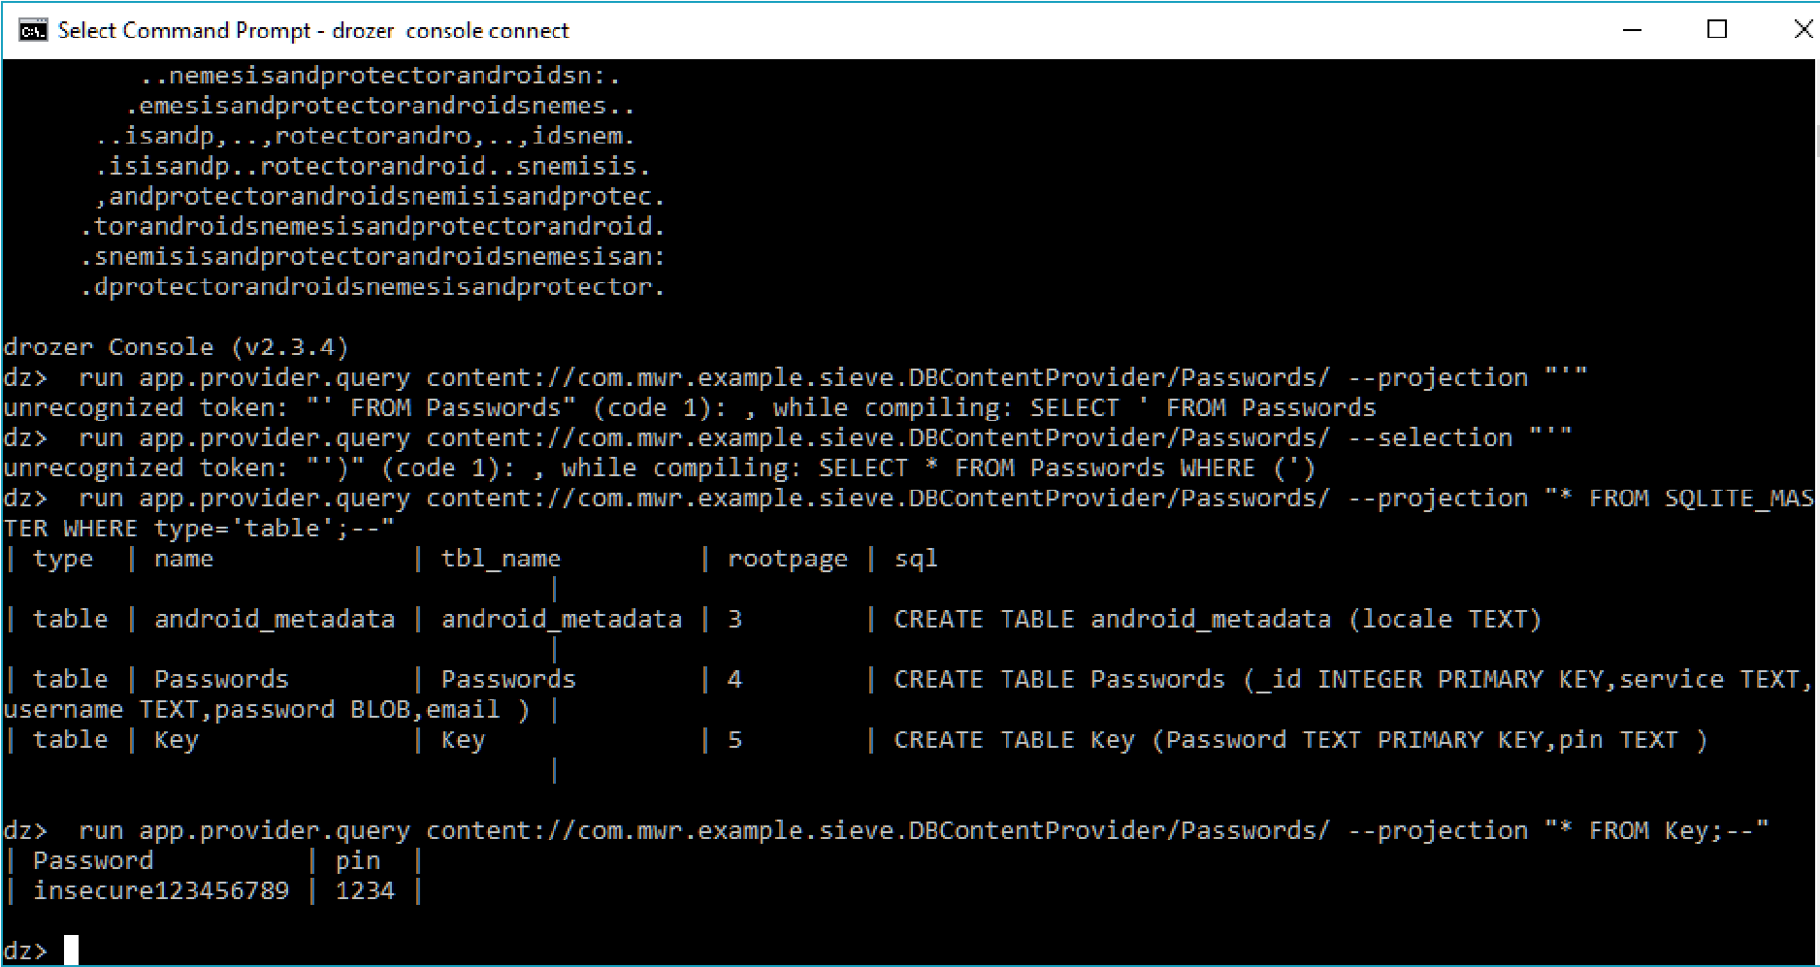

### Impact

Full disclosure of user’s master password, email addresses, application passwords, pins, and other sensitive details.

### Recommendations

Ensure that the all content providers require strict permission to interact for interaction.

|  |  |
| --- | --- |
| **3. Database-Backed Content Providers (Directory Traversal)** | |
| **Risk** | **HIGH** |
| **Locations(s)** | content://com.mwr.example.sieve.FileBackupProvider/ content://com.mwr.example.sieve.FileBackupProvider |
| **Description** | |

A content provider can provide access to the underlying file system. This allows apps to share files, where the Android sandbox would otherwise prevent it.

### Observations

|  |  |
| --- | --- |
| Since we can reasonably assume that FileBackupProvider is a file systembacked content provider and that the path component represents the location of the file we want to open, we can easily guess the content URIs for this and use a drozer module to read the files:      Reading the /etc/hosts file is not a big problem (it is world readable anyway) but another drozer module allowed us to find additional content  URIs that most contain more sensitive information, such as | |
| |  | | --- | | content://com.mwr.example.sieve.FileBackupProvider/data | | , as soon below: |
|  |

We were able to copy

the application’s database from the device to the

locale machine, where it can be browsed with sqlite to extract not only

the user’s encrypted passwords, but also their master password:

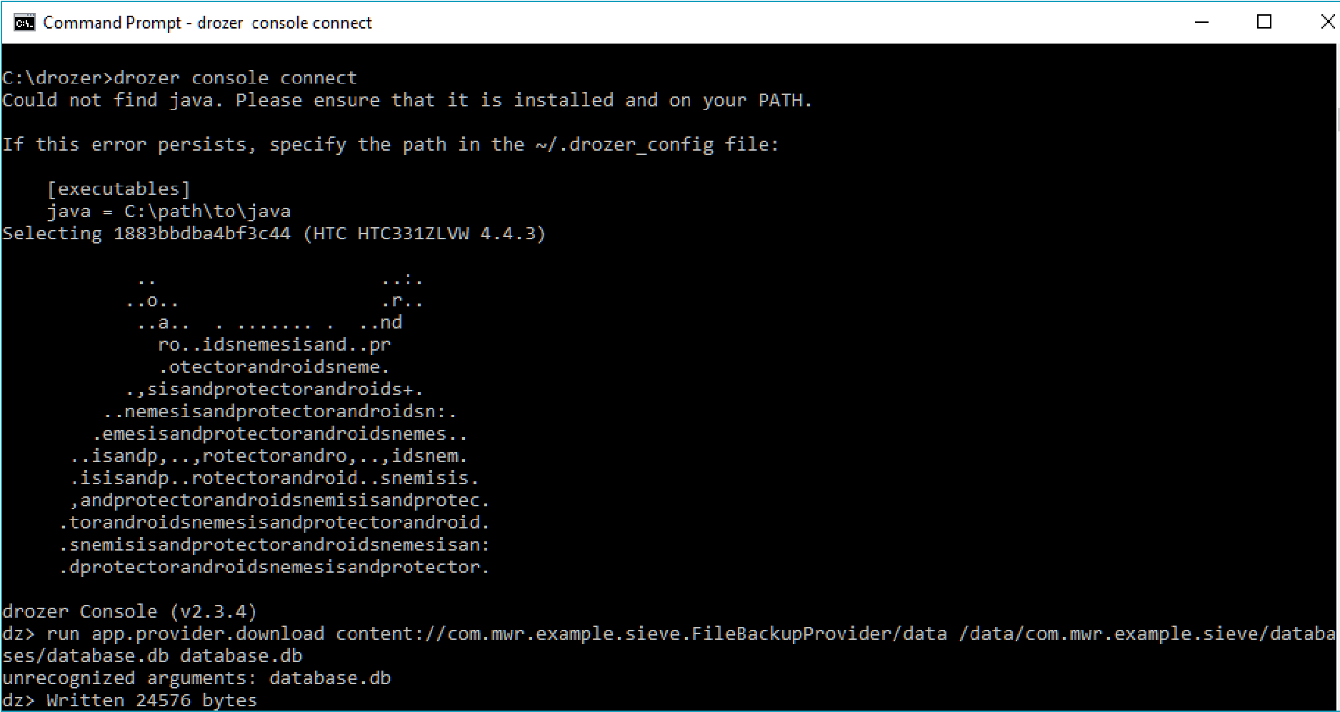

### Impact

Full disclosure of user’s master password, email addresses, application passwords, pins, and other sensitive details.

### Recommendations

Disable content provider access to the device’s underlying filesystem.

# SOCIAL ENGINEERING FINDINGS

# SCOPE

SampleCorp tasked us with a social engineering assessment in order to evaluate the response of employees in regards to social engineering tactics.

The scope was agreed as follows:

1. Spear Phishing Emails with request to respond with information
2. Spear Phishing Emails with call to action to click a link
3. Voice Phishing Calls

Names and Emails provided by the customer to be targeted in the Social Engineering Testing:

|  |  |  |  |  |
| --- | --- | --- | --- | --- |
| **First** | **Last** | **Role** | **Work Phone** | **Email** |
| Bill | Best | Network Admin | 555-555-1234 | bill@samplecorp.com |
| Stephanie | Engles | C.O.O | 555-555-1235 | stephanie@samplecorp.com |
| Clint | Hyde | C.T.O | 555-555-1236 | clint@samplecorp.com |
| Amanda | Jameson | Investor Relations | 555-555-1237 | amanda@samplecorp.com |
| Alex | Johnson | HR Manager | 555-555-1238 | alex@samplecorp.com |
| Jack | Johnson | I.T. Director | 555-555-1239 | jack@samplecorp.com |
| James | Johnson | Operations | 555-555-1331 | james@samplecorp.com |
| James | Murphy | Sales Manager | 555-555-1332 | james@samplecorp.com |
| Bill | Musco | Legal | 555-555-1333 | bill@samplecorp.com |
| Adam | Pierce | Director of Digital Strategy | 555-555-1334 | adam@samplecorp.com |
| Rocky | Smalls | C.E.O | 555-555-1335 | rocky@samplecorp.com |
| Jack | Waldorf | C.I.S.O | 555-555-1336 | jack@samplecorp.com |
| Archie | Wang | General Council | 555-555-1337 | archie@samplecorp.com |
| Josh | Weedin | Marketing Intern | 555-555-1338 | josh@samplecorp.com |
| Jeff | Woodward | Compliance Officer | 555-555-1339 | jeff@samplecorp.com |

# SOCIAL ENGINEERING RESULTS

|  |  |
| --- | --- |
| **Result Classification** |  |
| **Vulnerabilities Found** | Yes |
| **Email Exposure** | Yes |
| **Spear Phishing** | Yes |
| **Voice Phishing** | Yes |
| **Malicious USB Payloads** | No |
| **Sensitive Data Exfiltrated** | No |
| **Overall Risk** | **LOW** |

PrimoConnect was able to obtain two company emails via OSINT techniques, one of which was the company CEO’s email address. In addition, the spear phishing campaign resulted in a failure rate of

35.7%, as employees seemed eager to respond to unofficial email addresses with sensitive information.

# Social Engineering Detailed Findings

# Email Exposure Report

Only 2 Email address were found using Open Source techniques.

Emails found:

contact@samplecorp.com rocky@samplecorp.com

The contact@samplecorp.com address is listed on the client website:

<https://samplecorp.com/contact/>

The rocky@samplecorp.com is listed on the client website as well:

<https://samplecorp.com/meet-our-leaders/>

**Summary on exposure:**

Given the relatively small size of the company, only 2 email addresses are publicly available. However, one of these emails is the address of the company CEO, making it very easy for a social engineer to spoof mail coming from this account, which would be quite convincing should most employees receive and read it. No one wants to ignore the boss!

In addition, it should be noted that using just the first name in an email address could give further clues to a social engineer and one could assume that all other staff uses similar email addresses in a firstName@companyname.com format.

# Spear Phishing Report 1

The following 15 users received targeted email phishing attempt:

bill@samplecorp.com stephanie@samplecorp.com clint@samplecorp.com amanda@samplecorp.com alex@samplecorp.com jack@samplecorp.com james@samplecorp.com james@samplecorp.com bill@samplecorp.com adam@samplecorp.com rocky@samplecorp.com jack@samplecorp.com archie@samplecorp.com josh@samplecorp.com jeff@samplecorp.com

For this spear phishing exercise, we have created a Gmail address kristine.ascanio22@gmail.com and pretexted to be her in her role as executive assistant.

The following template has been used:

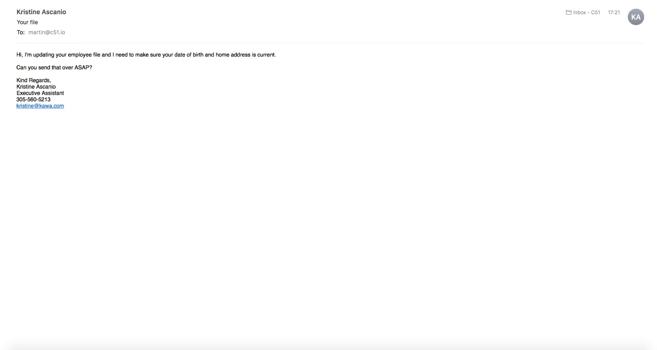

Out of 15 sent emails, 1 Email bounced and couldn’t be delivered as per screenshot below:

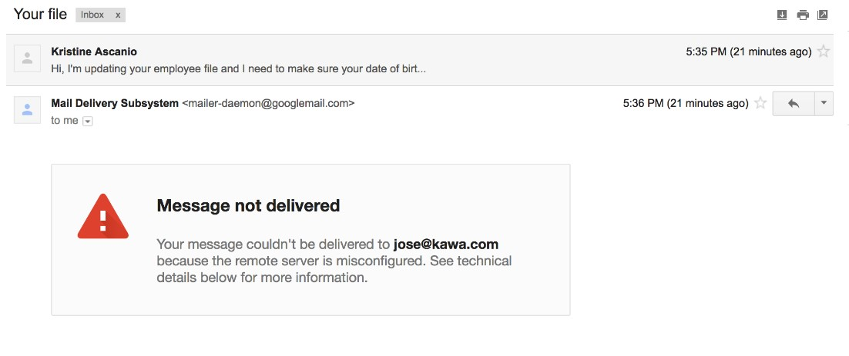

Out of the remaining 14 Phishing emails, 5 users replied with the requested information. This equals a failure rate of 35.7%

# Voice Phishing Report

We have grouped the users into 8 groups (G1 – G8). All received automated Voice calls with different calls to action, as described in the graphic below.

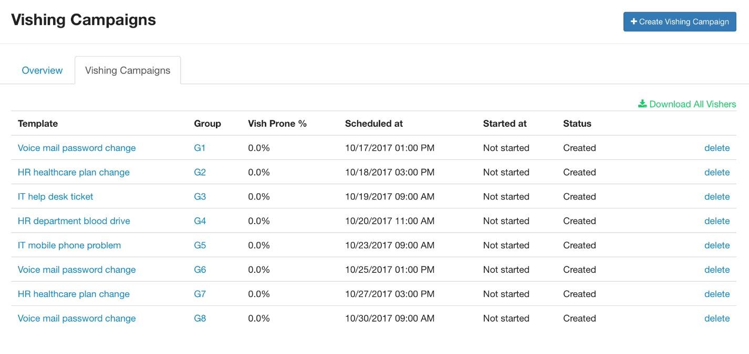

**Voice Phishing Results:**

**Group 1 (No failure)**

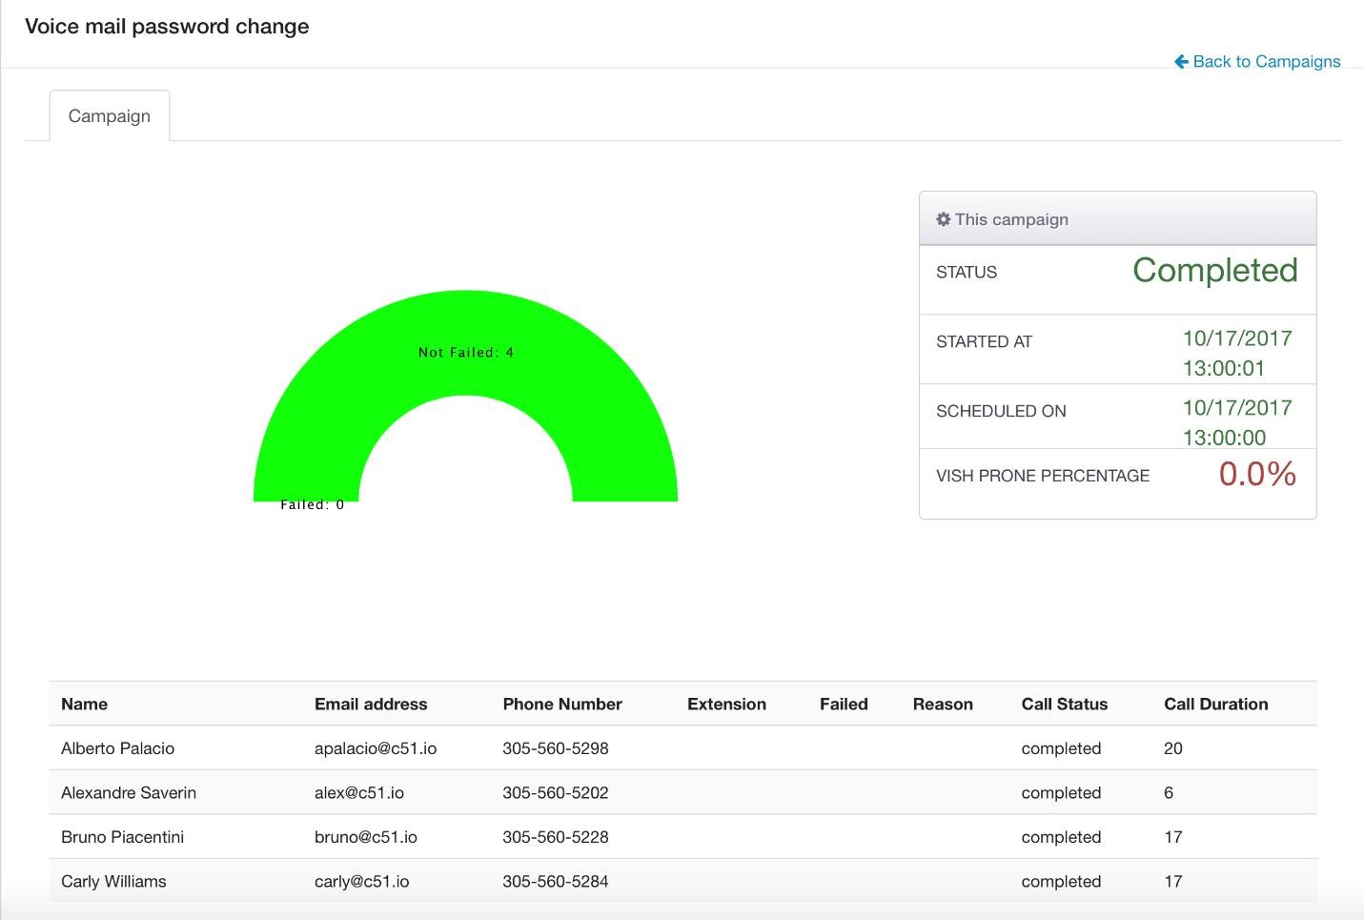

**Group 2 (**

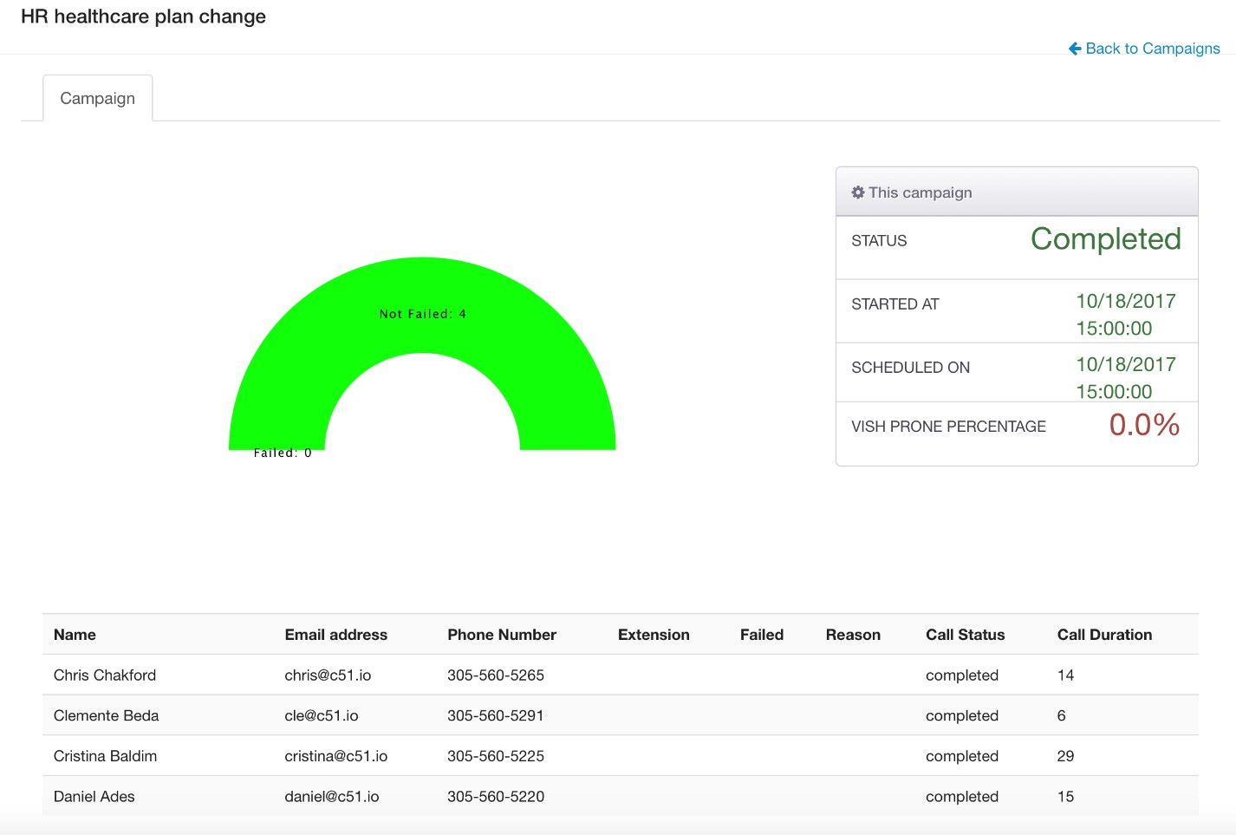

**Group 3 (**

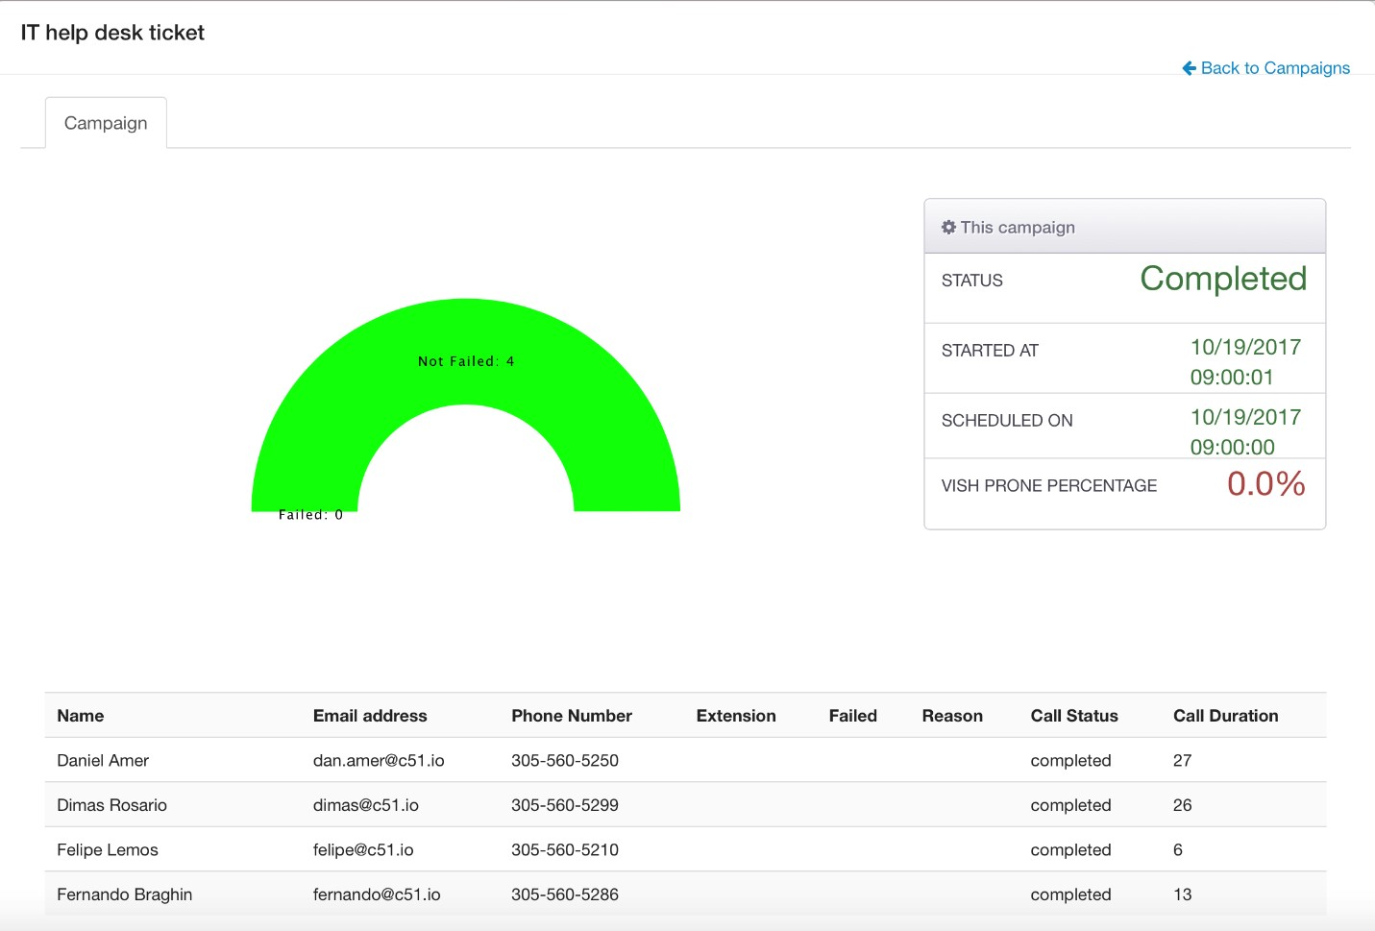

**Group 4 (**

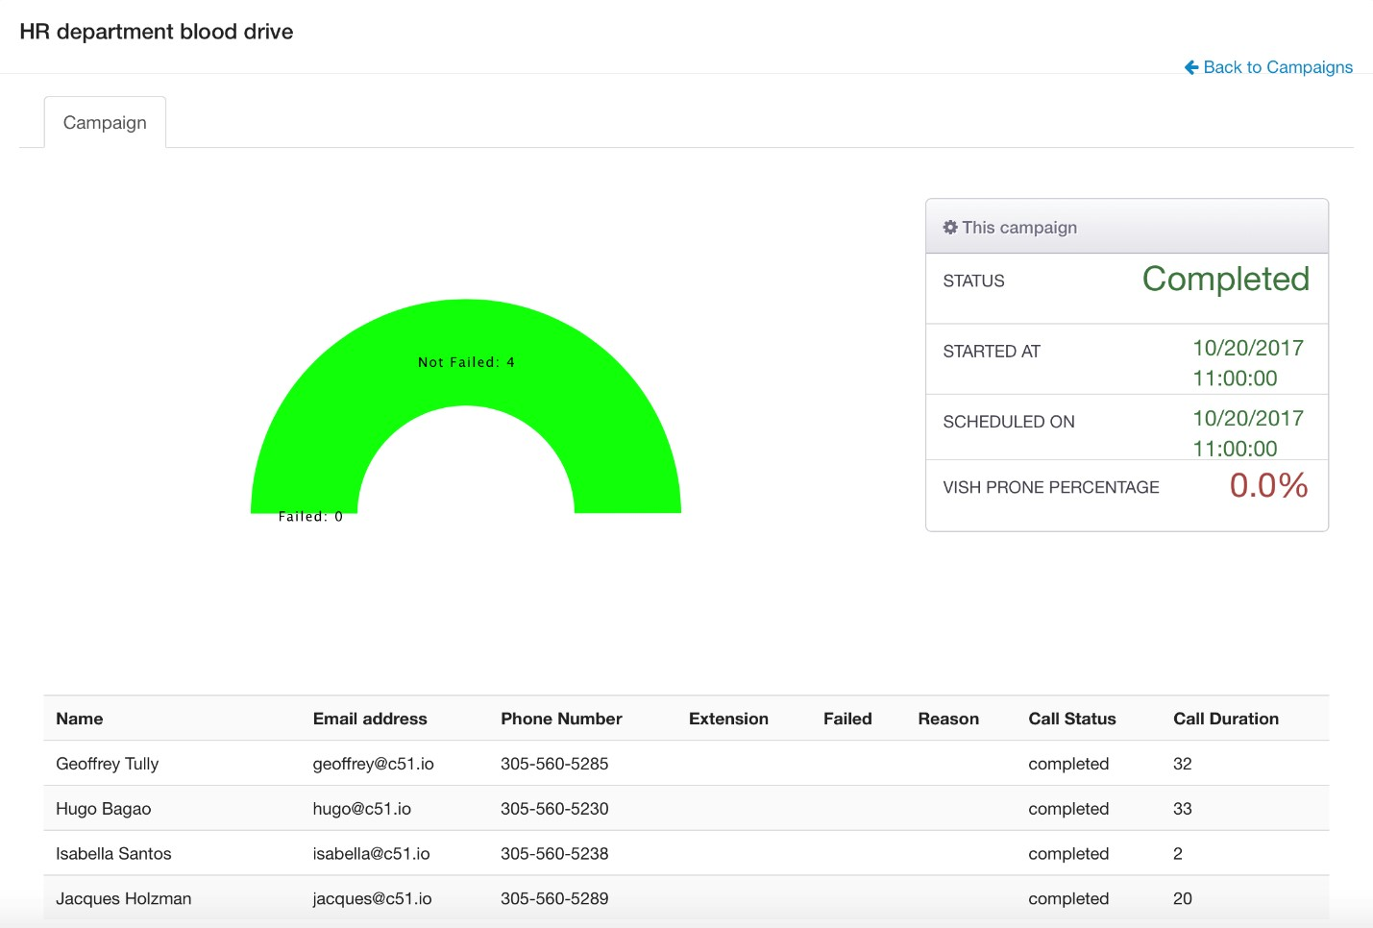

**Group 5 (**

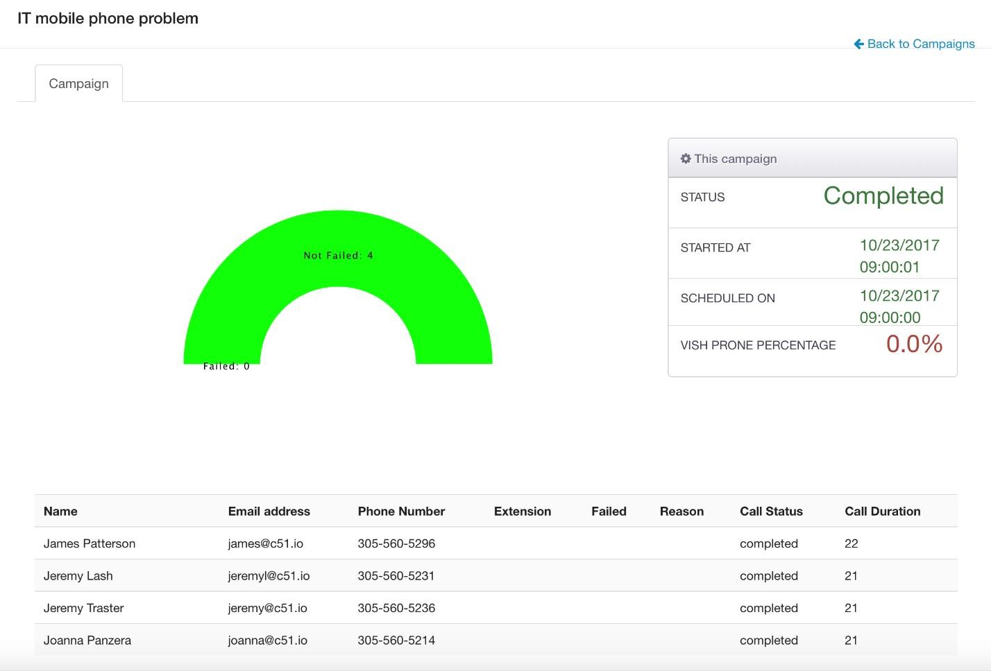

**Group 6 (**

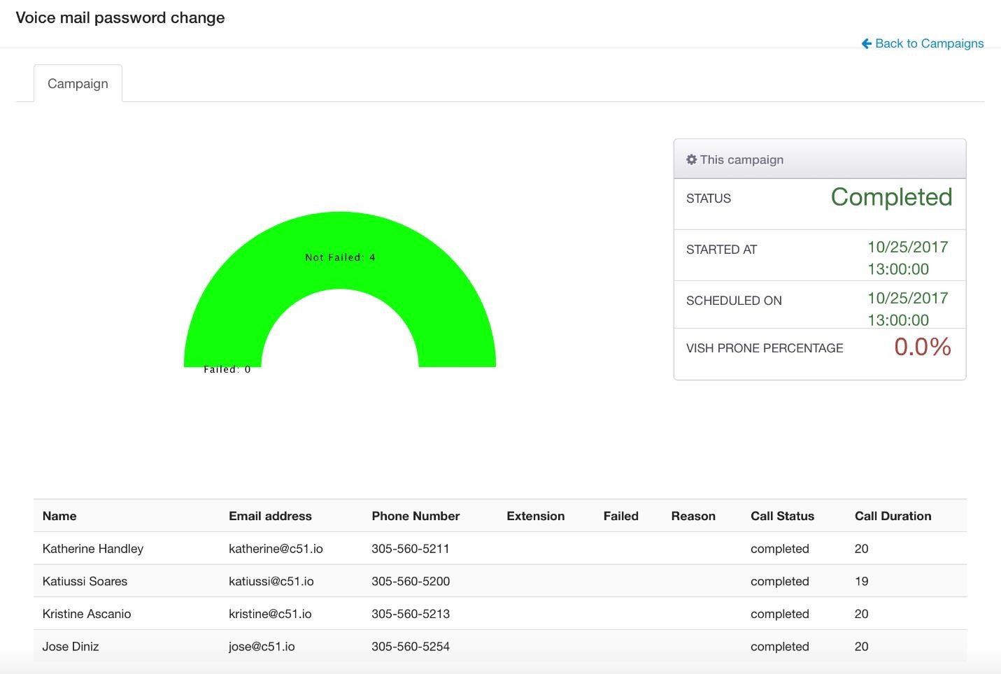

**Group 7 (**

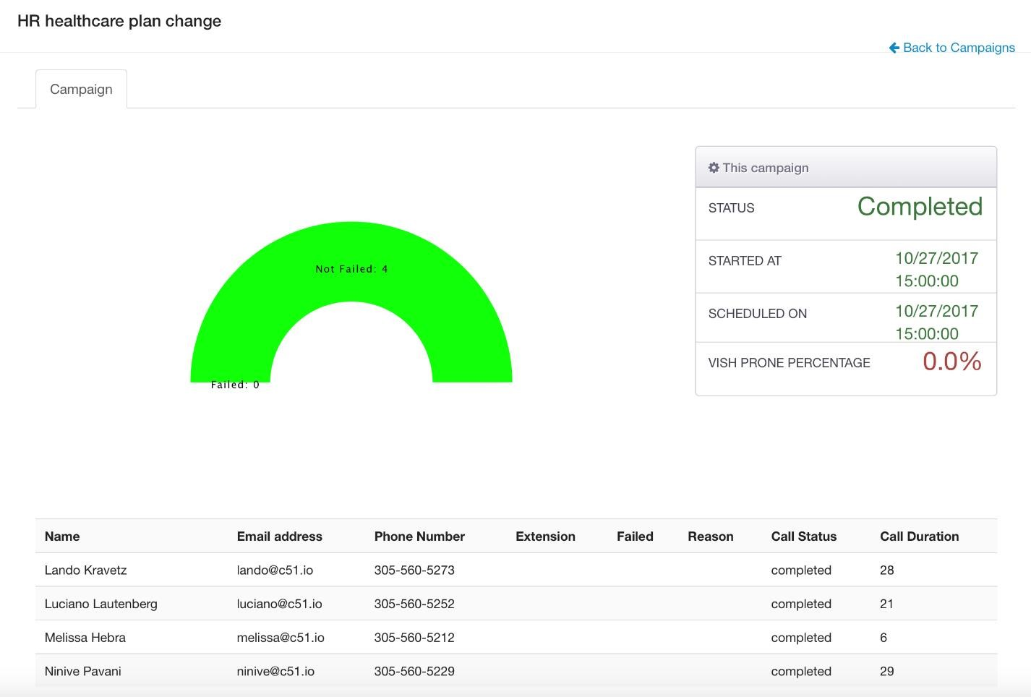

**Group 8 (**

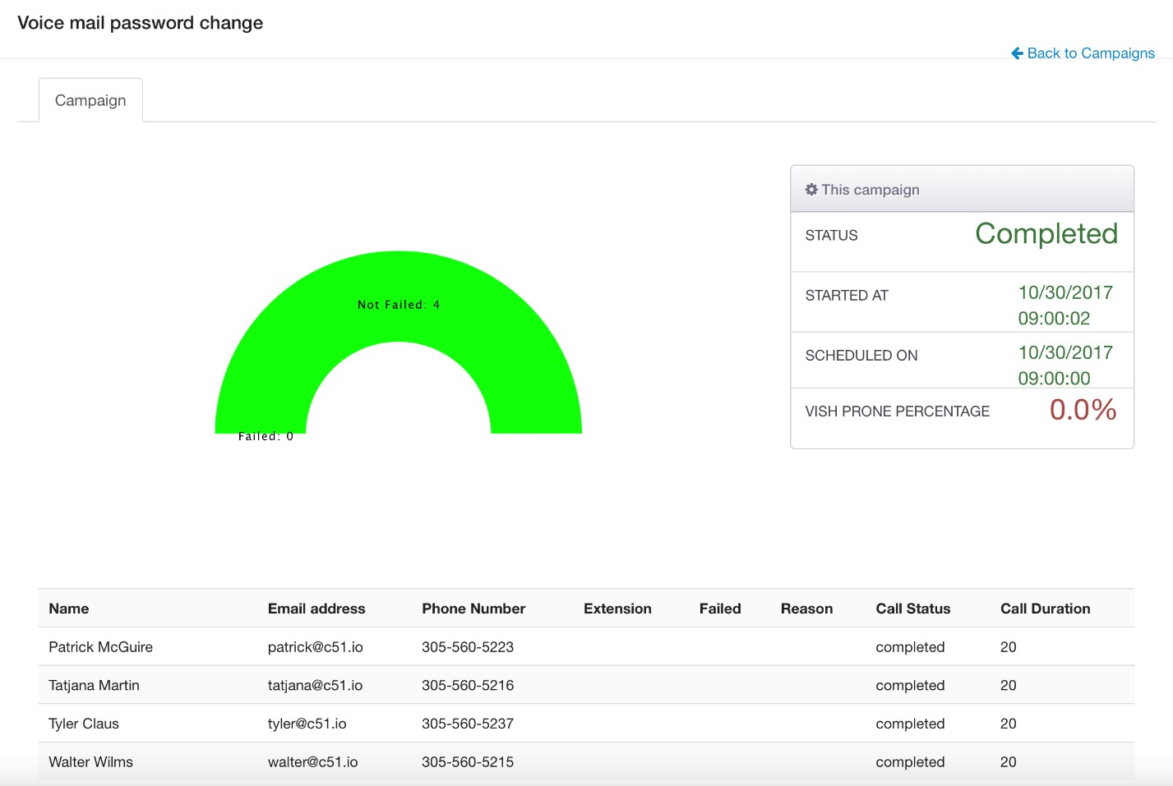

# Malicious USB Payloads

We created 2 malicious Payloads (an Excel file and a Word file both with an embedded Macro). Both files work under MS or Apple Mac OS operating systems. We have supplied the 2 payloads to the customer and our recommendation was to put out 10 USB drives in the office. 5 USB sticks contained the Excel file and 5 USB sticks should contained the word file.

The word file name was: “Free Amazon Voucher Codes” whereas the Excel file name was “Executive Management Payroll 2017”. In order to make the success rate higher we recommended putting a simple label on the USBs with the same names as the files in order to entice people to plug it in.

**USB Results:**

From October 16th 2017 to November 10th 2017 none of the USB payloads have been activated. No user opened any of the provided files and no user enabled Macros upon opening.

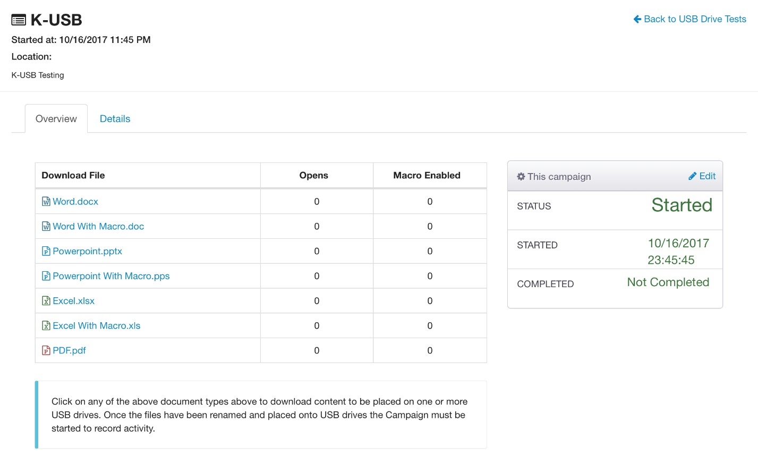

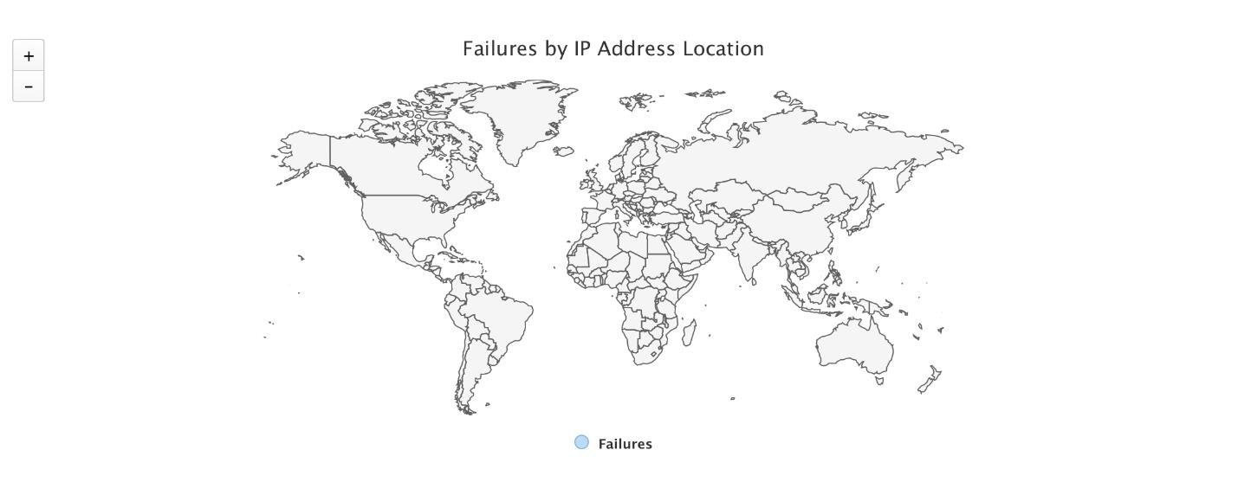

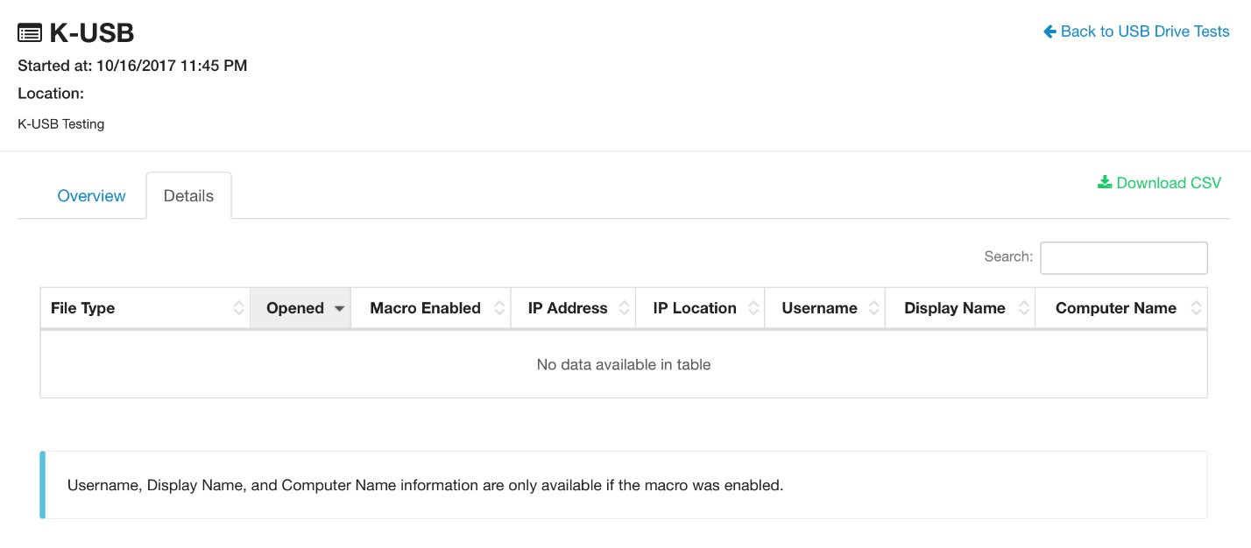

# LIMITATIONS & RISK SCORING

# LIMITATIONS

* Security issues that could potentially disrupt the Client environment were not fully tested.
  + Security issues that could negatively disrupt and impact normal system operations, including Denial of Service (DoS) or buffer overflow attempts, were not fully tested as part of this assessment.
* Technical testing activities were limited to a finite time period.
  + While PrimoConnect’s methodology included both automated and manual testing to identify and attempt exploitation of the most common security issues, testing was limited to a finite period of time. Malicious users may be able to discover and attempt additional security issues over a longer period of time or through other methods such as social engineering.
* Social Engineering o Social Engineering attacks were not in scope for this assessment.
* Client-Side Attacks o Client-side attacks were not in scope for this assessment.

# RISK RATING SCORE CALCULATION

PrimoConnect calculates an overall Risk Rating Score based on version 2 of the Common Vulnerability Scoring System (CVSS), by measuring it against six distinct criteria. The overall Risk Rating score per vulnerability is calculated as follows:

|  |  |  |
| --- | --- | --- |
| **Measurement Type Description[1]** | | |
| **AV** | **Access Vector** | This metric reflects how the vulnerability is exploited. The more remote an attacker can be to attack a host, the greater the vulnerability score. |
| **AC** | **Access**  **Complexity** | This metric measures the complexity of the attack required to exploit the vulnerability once an attacker has gained access to the target system. |
| **Au** | **Authentication** | This metric measures the number of times an attacker must authenticate to a target in order to exploit a vulnerability. This metric does not gauge the strength or complexity of the authentication process, only that an attacker is required to provide credentials before an exploit may occur. |
| **C** | **Confidentiality**  **Impact** | This metric measures the impact on confidentiality of a successfully exploited vulnerability. Confidentiality refers to limiting information access and disclosure to only authorized users, as well as preventing access by, or disclosure to, unauthorized ones. |
| **I** | **Integrity**  **Impact** | This metric measures the impact to integrity of a successfully exploited vulnerability. Integrity refers to the trustworthiness and guaranteed veracity of information. |
| **A** | **Availability**  **Impact** | This metric measures the impact to availability of a successfully exploited vulnerability. Availability refers to the accessibility of information resources. |

# RISK RATING SCALE

The Risk Rating Score assigned to each exploitable vulnerability finding is then translated into a **CRITICAL**, **HIGH**, **MEDIUM**, or **LOW** Risk Rating to simplify reporting, analysis and remediation planning.

|  |  |
| --- | --- |
| **Risk Rating** | **Description** |
| **CRITICAL** | High Severity issues that can be exploited in isolation, with no additional steps necessary, that may provide total compromise of the system. |
| **HIGH** | A **7-10** on the Risk Rating scale. Severe issues that can easily be exploited to immediately impact the environment. |
| **MEDIUM** | A **4-6.9** on the Risk Rating scale. Moderate security issues that require some effort to successfully impact the environment. |
| **LOW** | A **0-3.9** on the Risk Rating scale. Security issues that have a limited or trivial impact to the environment. |
| **INFO** | These vulnerabilities represent significantly less risk and are informational in nature. These items can be remediated to increase security. |

# APPENDIX

1. https://www.first.org/cvss/v2/guide